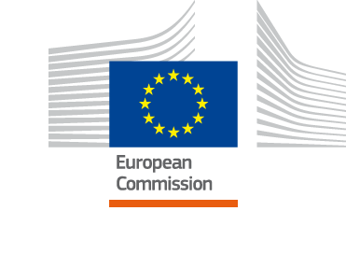
Partnership Instrument Monitoring System (PIMS)

Guidelines
v.1.3

October 2020
___________

Project carried out on behalf of the European Commission

Service of Foreign Policy Instruments

Contents
Acronyms iv
1. Introduction 1
1.1. What is this guide? 1
1.2. Who should use this guide? 1
1.3. How to use this guide? 1
2. Glossary 2
3. The Partnership Instrument Monitoring System (PIMS) 5
3.1. Basic principles 5
3.2. Components 5
4. Intervention logic 6
4.1. What is an Intervention Logic? 6
4.2. Levels of an Intervention Logic 6
4.3. What is the Intervention Logic of the PI? 7
5. Logframe matrix 12
5.1. What is the Logframe Matrix? 12
5.2. What results are expected and how will they be achieved? 12
5.2.1. Developing a results chain 13
5.2.2. Drafting the assumptions 14
5.3. How will the Action be monitored? 17
6. Indicators 22
6.1. What are indicators? 22
6.2. When to select and develop indicators 23
6.3. How to choose indicators? 23
6.4. PI Core indicators 24
6.4.1. Activity Indicators 24
6.4.2. Core Output Indicators 25
6.4.3. Core Outcome Indicators 27
6.4.4. Core Impact Indicators 30
6.5. Customised Indicators 32
6.5.1. Why using customised indicators? 32
6.5.2. How to develop customised indicators? 32
6.6. How to use indicators? 34
7. Data collection strategy 35
7.1. Planning data collection and analysis 35
7.2. Deciding on methods 37
7.3. Overview of some possible data collection tools 37
7.3.1. Desk-based research 40
7.3.2. Interviews 40
7.3.3. Focus groups 41
7.3.4. Surveys 41
7.4. Which tools are most suitable for my needs? 42
7.5. Controlling for Bias 44
8. Reporting 45
9. Quality review of reporting 47
10. For additional information 48
Annex 1: PI Core Indicators 49
A. List of indicators, unit of measurement and disaggregation 49
Output 49
Outcome 51
Impact 53
B. PI core indicators fiches 54
Annex 2: Intervention Logic Template 55
Annex 3: Logframe Matrix 57

This guide has been prepared by Coffey International Development as part of the project “Technical Assistance for the Partnership Instrument Monitoring and Reporting System”.

Acronyms
A Activity
AAP Annual Action Programme
DG Directorate General
EEAS European External Action Service
EU European Union
EUPOP European Union Public and Outreach Partnership
FPI Service for Foreign Policy Instruments
IL Intervention Logic
IMP Impact
IP Implementing Partner
LFM Logframe Matrix
MIP Multiannual Indicative Programme
OC Outcome
OP Output
PI Partnership Instrument
PIMS Partnership Instrument Monitoring System
PM Project Manager
PSF Policy Support Facility
SDGs Sustainable Development Goals
TAIEX Technical Assistance and Information Exchange

Introduction

What is this guide?
This guide presents the key features of the Partnership Instrument Monitoring System (PIMS). It is designed to support Partnership Instrument (PI) stakeholders in monitoring the results of PI Actions. PI stakeholders are (1) FPI.4 (project managers in Brussels and EU Delegations), (2) PI users (the thematic DGs of the European Commission, the European External Action Service (EEAS) or EU Delegations which use the PI funding) and (3) implementing partners (contractors, beneficiaries or other organisations implementing PI Actions).
The guide provides information on how to:

- Monitor the performance of PI Actions
- Collect reliable and comprehensive data on PI Actions
- Build the monitoring and reporting capacity of relevant PI stakeholders

Many of the tasks and processes described in this guide will be carried via OPSYS in the future. OPSYS is the new online platform for EU-funded projects in the field of external relations. It will become the operational tool supporting in particular project design, monitoring and reporting. The tasks and processes will not change, OPSYS will support them. For more information on OPSYS, please refer to the OPSYS guidelines.
There will likely be a new generation of financing instruments post-2020. Guidelines will be updated as relevant. This guide remains valid for PI-funded actions.

Who should use this guide?
- A PI project manager is an FPI staff at headquarters and EU Delegations, responsible for the operational management of PI Actions. Their involvement ranges from support to the design of the Actions, the supervision of their implementation and monitoring, and the quality review of reporting.
- A PI user is a thematic Directorate General (DG) of the European Commission, the EEAS or an EU Delegation which has proposed a PI Action and will use / benefit from its results. PI users design the Action, provide content steer and oversee its implementation together with the PI project manager.
- An implementing partner (IP) is the beneficiary, contractor or organisation which carries out a PI Action. IPs are responsible for implementing and monitoring PI Actions, as well as reporting on the results achieved.

How to use this guide?
For a glossary of key terms | see | Section 2
For a quick overview of the key elements of the PIMS | see | Section 3
For an introduction to intervention logics | see | Section 4
For guidance on how to use the logframe matrix | see | Section 5
For guidance on how to select and/or customise indicators for your Action | see | Section 6
For tips on planning data collection | see | Section 7
For dos and don’ts on reporting | see | Section 8
For an introduction to conducting a quality review of reporting | see | Section 9

This document represents version 1.2 of the guidance. Periodic updates may be issued at later dates.

Glossary
Activity – Task undertaken to produce outputs. Each PI Action is composed of an activity or a set of activities.

Assumption – Hypotheses about factors or risks which could affect the progress or success of an Action.

Attribution – The identification of a causal link between observed (or expected to be observed) outcomes or impact and a specific PI Action. Attribution represents the extent to which observed results can be attributed to a specific PI Action.

Baseline – Starting point of the Action. A baseline provides information on the situation the PI Action aims to change. It provides a reference point for assessing results, as it establishes a basis for comparing the situation before and after the Action. Normally, each indicator would have a baseline value but qualitative or descriptive baselines are also important.

Contribution – Contribution is when a PI Action contributed to an outcome / impact achievement, or that PI Action was one of the factors that helped bring about a particular change. We determine contribution by establishing an evidence-base and carefully analysing the cause-and-effect chain that links the PI Action to the result, possibly noting other factors that may also have contributed to the change.

Data collection tools – Methods used to identify information sources and collect information during monitoring or during an evaluation (e.g. questionnaires, interview guides, focus group discussion guide, etc.).

Evaluation – The systematic and objective assessment of an on-going or completed project, programme or policy, its design, implementation and results. The aim is to determine the relevance, effectiveness, efficiency, coherence and added value. An evaluation should provide information that is credible and useful, enabling the incorporation of lessons learned into decision–making process. Evaluation is different to monitoring in terms of depth, scope and purpose. Evaluations are usually more in-depth than monitoring and often involve search for evidence-based progress towards the outputs, outcomes, etc.

Goal – Synonym for "objective".

Impact / Overall Objective – Long-term result(s) to which an Action is expected to contribute in the social (incl. political), economic and environmental global context involving other stakeholders. Impacts are in the sphere of indirect influence of the intervention.

Implementing partners – The beneficiary, contractor or organisation which carries out PI Actions.

Indicators – Quantifiable or qualitative variables or factors that can be observed, in order to provide reliable information to assess / measure performance and change, or progress towards the achievement of outputs, outcomes and impact over time.

Inputs – The political, technical, and financial and human resources used for the PI Action.

Intervention logic – Management tool used in the design of PI Actions. It shows the logical link from an intervention's input to its output and, subsequently, to its results and impacts.

Logframe – Management tool used in the design and monitoring of PI Actions. It involves identifying strategic elements (inputs, outputs, specific objectives and overall objectives) and their causal relationships, indicators, and the assumptions or risks that may influence success and failure. It facilitates planning, execution and evaluation of a PI Action.

Monitoring – A continuous function that uses systematic collection of data on specified indicators to provide management and the main stakeholders of an ongoing intervention with indications of the extent of progress and achievement of objectives and progress in the use of allocated funds.

OPSYS –Operational information System of the European Commission; it will support the operational, legal and financial management of all external actions, including PI Actions.

Outcome / Specific Objective – Medium-term result an Action is expected to achieve in the social (incl. political), economic or environmental area (of the Action) and/or on direct addressees of the Action (participants / target groups). In order for an outcome to materialise, a change in behaviour/perception/engagement is necessary. Outcomes are expected to materialise within the lifetime of the Action and are under its direct influence. However, other external factors and players also influence the outcome and participants / target groups.

Output – Direct products generated by activities under a PI Action, produced or accomplished with the resources allocated to the Action. Outputs are in the sphere of control of an Action.

Performance – The degree to which an intervention or a partner operates according to specific criteria / standards / guidelines or achieves results in accordance with stated goals or plans.

PI user – Thematic Directorate General (DG) of the European Commission, EEAS or EU Delegation which has proposed a PI Action and will use / benefit from its results. During the implementation phase, it provides technical and/or political guidance.

Process – How a policy decision is made in any area (e.g. climate change, migration, trade, standardisation, etc.). The PI funds Actions which aim to influence EU partners’ policy-making. An activity (e.g. a seminar on the fight against counterfeiting or a conference on climate change) or a series of activities (e.g. a series of stakeholder workshops on ICT standards and regulatory cooperation or matchmaking sessions between EU businesses and overseas businesses for the development of green technologies) are implemented to influence how EU partners approach / decide on a particular topic.

Project manager – FPI staff (at headquarters or EU Delegation) who is responsible for an Action’s management and overseeing its implementation.

PSF – Policy Support Facility; one of the implementation modalities of the PI.

Quality assurance – Quality assurance encompasses any activity that is concerned with assessing and improving the merit or the worth of an intervention or its compliance with given standards.

Results – Results include the output, outcome or impact (intended or unintended, positive and / or negative) of an Action. While activities describe what is being done, results describe ensuing changes.

Results chain – The causal sequence for an intervention that stipulates the necessary sequence to achieve desired results. It starts from inputs, moving through activities and outputs, and culminating in outcomes and impacts.

Standalone Action – One of the implementation modalities of the PI.

TAIEX – Technical Assistance and Information Exchange; one of the implementation modalities of the PI.

Target – Indicates the desired result for a given indicator at the end of the Action and beyond.

Triangulation – The combined use of theories, sources or types of information, or types of analysis to verify and substantiate an assessment.

Figure 1: How does the PIMS fit in the Action cycle?

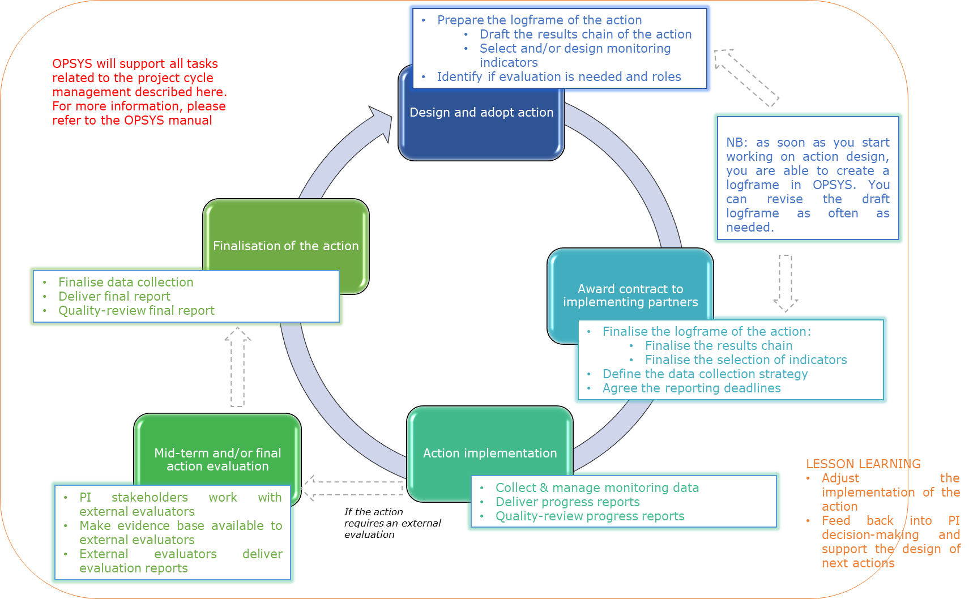

The Partnership Instrument Monitoring System (PIMS)

Basic principles
Monitoring is done to provide reliable information on the performance of PI Actions and the achievement of their intended results. It is about counting the right thing at the right time.
The PI is a foreign policy instrument, which means that its results are political – it aims to influence processes. The PI intervenes in very diverse areas (climate change, trade, public diplomacy, etc.) and at different levels (bilateral, regional and multilateral). Monitoring the results of an Action should focus on the processes the instrument aims to influence and the activities and outputs that lead towards influencing those processes.
Monitoring at Action level is carried out and then aggregated up to the instrument level. This gives information on “the big picture” which allows us to assess the performance of the PI as a whole.
Monitoring is the joint responsibility of:
- FPI.4 project managers (in Brussels and EU Delegations),
- PI users (the thematic DGs of the European Commission, EEAS or EU Delegations which use the PI funding), and
- Implementing partners (which implement the individual Actions).

Components
The PIMS consists of the following five elements. Different elements are relevant to different stakeholder groups as shown in the table below:
 | Who will be the main user? | FPI.4 project managers | PI users | Implementing partners
Intervention logic | - At PI level: To understand what is expected to happen in the short, medium and long term | Ѵ | Ѵ
Logframe matrix | - To frame individual Actions in line with the logic of the PI  - To set realistic objectives within the timeframe of the Action  - To detail monitoring for the Action | Ѵ | Ѵ | Ѵ
Indicators | - To select indicators and/or develop indicators to track results  - To ensure data can be collected | Ѵ | Ѵ | Ѵ
Data collection | - To plan for data collection and ensure it is timely, budgeted for, comprehensive and reliable | Ѵ |  | Ѵ
 | - To collect data on Actions’ results |  |  | Ѵ
Reporting | - To draft clear deliverables in the form of interim and final Action reports, including indicator values |  |  | Ѵ
 | - To perform a quality review of the reporting | Ѵ | v
The European Commission has set up an online platform, OPSYS, to support the design of projects, project management, monitoring and reporting. The different functionalities of the platform are progressively rolled out. In the future, all the steps described in this guidance will be implemented in OPSYS. Remember to check what is already available online!

Intervention logic
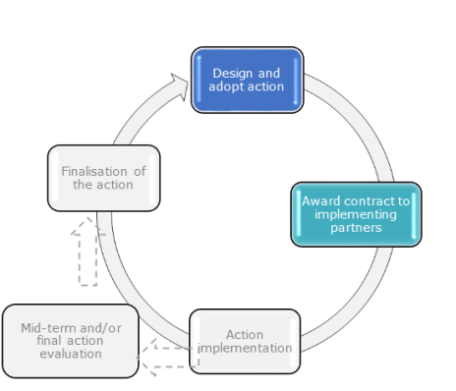
The objective of the intervention logic is two-fold:
- Identify key components of an intervention and the relationships between them
- Identify, consider and take into account the assumptions

What is an Intervention Logic?
An Intervention Logic (IL) is a model that graphically illustrates the different components of an intervention. These are inputs, activities, outputs, specific objectives (outcomes) and overall objectives (impacts). The diagram represents how they are expected to link with each other, what is called a results chain. An IL provides a blue print for a theoretical “optimal” intervention against which the actual intervention can be assessed. The graphic representation of the IL is often accompanied by a narrative, which provides context and further elaborates on the depicted relationships between the different components of the intervention.

Levels of an Intervention Logic
The IL is operationalised on several interconnected levels. At the bottom are the needs / problems that the intervention seeks to address, as well as the opportunities that it will seek to make use of in order to achieve the objectives set.
A typical results chain can be described as follows:
Figure 2: Levels of an Intervention Logic
- The resources available for the implementation of the intervention (political, technical, financial and human) are the inputs of the intervention.
- Activities are concrete tasks undertaken to produce outputs.
- Outputs are the direct products of activities produced or accomplished with the resources allocated to an intervention (inputs).
- Outputs result in the realisation of specific objectives (outcomes), the medium-term results an Action is expected to achieve in its social (incl. political), economic and environmental area and/or on its direct addressees (participants/ target groups).
- Overall objectives (impacts) are the long-term results to which an Action is expected to contribute in the social (incl. political), economic and environmental global context involving other stakeholders.
Articulating the levels of the intervention logic helps us to see whether or not the expected inputs and activities are appropriate to achieve the intended results (outputs, outcomes and impacts) and that these align with wider policy objectives.
When designing an intervention, a number of other elements are also important and should be presented in the IL too. They are:
- Assumptions. They are hypotheses about factors or risks which could affect the progress or success of an intervention. An IL is inevitably built around assumptions. They can be political, economic, social, technological, legal and / or environmental. It is useful to map these out as much as possible when the IL is developed to ensure that the design of the intervention is adequate and the implementation is tailored.

For example, an intervention may assume that there is continued political support by Countryland despite local or national election results. It is important to highlight these assumptions as the election results may lead to the discontinuation of the support of Countryland for the intervention.

- Pre-conditions. These are conditions that need to be met prior to the commencement of the intervention and must hold throughout its implementation for the success of the intervention. They relate to the general environment in which the intervention is implemented and the predisposition of parties (the EU and its partners) to work together.

What is the Intervention Logic of the PI?
This section provides an overall understanding of the PI’s intervention logic. It describes the “big picture” to which individual Actions, funded by the PI, contribute. As explained above, the IL graphically illustrates the components of an intervention (see figure 2). As an aid to reading the graphic depiction of the PI’s intervention logic, the following narrative gives an overview of the PI’s main features, as well as providing illustrative examples taken from existing PI Actions. See figure 3 for the overall PI IL.
As a starting point, a number of pre-conditions need to be met prior to the implementation. If these pre-conditions are not met, an intervention cannot and should not take place i.e. no activity should be implemented. Typical pre-conditions would refer to key stakeholders’ commitment to the overall objective, the existence of a favourable context, availability of necessary resources, etc.
Table 1: Pre-conditions for the overall PI
The EU continues to be perceived as a key player on the global scene and a relevant partner.
The EU’s internal and external agendas are conducive to joint approaches.
A generalised commitment to the need to solve global/mutual challenges through combined efforts prevails.
Involved parties (i.e. the EU and its partners) are committed and willing to cooperate with each other.
Sufficient financial and human resources continue to be put at the disposal of the PI to fulfil its obligations in headquarters and in EU Delegations.
The equality of partners has been respected in the design of the Action.

The PI’s intervention logic also references key assumptions at different levels (input, activity, output and outcome) that must hold in order to move from one level of the intervention logic to the next, i.e. from inputs to the implementation of activities, from activities to outputs, from outputs to outcomes and from outcomes to impacts. Below are the components of the overall PI’s IL.

- Global aim: The global aim of the PI is to advance and promote EU and mutual interests. This objective aligns with the EU broader objectives and notably the strengthening of the EU as a global actor. The formulation of the global aim gives the flexibility to account for the evolving international context and of EU interests. It is a reflection of the foreign policy objectives of the EU.
- Overall Objectives (impacts): The combined social (incl. political), economic and environmental effects of the individual Actions funded through the PI should contribute to bring about actual changes in the relationships between the EU and third countries:
- To enhance EU bilateral, regional, inter-regional and multilateral cooperation and partnership strategies through:
  - Reinforcement of policy dialogues, and/or
  - Development, adoption, implementation of collective approaches and responses to challenges of global and/or mutual concern, in particular in the areas of climate change, energy and the protection of the environment.
- To promote the uptake of approaches and practices beneficial to the achievement of EU 2020 strategy in partner countries
- To improved access to partner country markets
- To enhance widespread understanding and visibility of the EU and of its role on the world scene.
At this level of the IL, the potential contribution of the PI to the overall objectives will also be influenced by many other external factors and actors and their interventions. In the diagram, it is described as a sphere of indirect influence.
- Specific Objectives (outcomes): At specific objective level, the Actions aim at influencing some processes or behaviour/perception/engagement and their sum at PI level will be the outcomes of the PI. Through achievement of specific objectives, the PI can contribute to its overall objectives / impacts.
Table 1: Correspondence table between Overall and Specific Objectives
Overall Objective in the intervention logic | Specific Objectives in the intervention logic
To enhance the EU’s bilateral, regional, inter-regional and multilateral cooperation and partnership strategies through:  1 - Reinforcement of policy dialogues and/or  2 – Development / adoption / implementation of collective approaches and responses to challenges of global and/or mutual concern, in particular in the areas of climate change, energy and the protection of the environment. | 1 - To influence processes related to EU cooperation and EU partnership strategies at bilateral, regional, inter-regional and international level;  2 - To influence processes addressing global and/or mutual challenges, with a special attention to climate change, energy and environmental protection
To promote the uptake of approaches and practices beneficial to the achievement of EU 2020 strategy in partner countries (not covered under Objectives 1 and 3) | To influence processes related to partner country approaches and practices beneficial to the achievement of EU 2020 strategy (not covered under PI objectives 1 and 3)
To improve access to partner country markets | To influence processes related to the improvement of conditions for accessing partner country markets
To enhance widespread understanding and visibility of the EU and of its role on the world scene. | To influence processes related to increased understanding and visibility of the EU and of its role on the world scene

Assumptions at specific objective (outcome) level
Other relevant interventions contributing to the same Overall Objective (Impact) achieve their own objectives and external circumstances do not negatively impact on the Action’s outcomes. The interest and commitment of the involved parties is maintained / sustained. The equality of partners has been respected in the implementation of PI-supported Actions (thus ensuring sustainability).

- Outputs: This level depicts the products generated by the specific activities implemented, and in turn is expected to have a direct influence on the achievement of outcomes (the next level up). For analytical purposes, outputs are grouped into four types, namely:
- Type 1: Direct benefits of events. This refers to the skills, knowledge, awareness and understanding, etc. that have been created in, or transferred between, individuals and companies as well as engagement and networking, etc. These benefits come as a result of participation in some type of event organised by an Action where the term “event” includes: visits, exchanges, study tours, business missions, technical meetings (of experts), conferences, debates, workshops, seminars and training sessions.
- Type 2: Knowledge-based products. These serve as a source of evidence for public and private stakeholders or for development of, and progress with, EU and common agendas e.g. studies, reports, publications, assessments, databases, roadmaps, guidelines, systems, policy briefs etc.
- Type 3: Outcome statements. These are the outputs of meetings, conferences, fora, etc. They are written statements rather than verbal ones.
- Type 4: Advocacy, awareness raising products. These are the outputs (e.g. press releases, opinion pieces) resulting from advocacy or awareness raising activities implemented for instance by EU public and outreach partnerships (EUPOP) and cultural diplomacy actions. In contrast to type 2, this group of outputs is linked to communication and visibility products that can bring the EU values and interest closer to audiences in partner country(ies) or region.
PI Actions are not limited only to these types of outputs, but these represent the most common outputs of Actions.
Assumptions at output level
Outputs are appropriate / sufficient in terms of quantity and quality. They are relevant/accepted by target groups, and manage to reach the right people (participants/target group). The outputs are acted upon/used, as well as managed properly. The complementary Actions and/or other programmes to which the Action is considered to be linked, are on schedule.

- Activities: They are implemented under the PI Actions and generate the outputs. There are three broad types that are implemented as part of the different Actions funded by the PI (though these should not be considered to be an exhaustive list):
- Type 1: Exchanges, events and knowledge sharing. These are activities which bring people together and facilitate the exchange of ideas, knowledge, working methods or interests such as conferences, seminars, trade missions, trainings, etc.
- Type 2: The provision of expertise, technical assistance. That includes the provision of expertise to implement the Actions under the PI, ranging from logistical assistance, technical knowledge on subject matter, analytical services, communication, etc. These services are the backbone of each Action and are provided by experts working for the implementing partner.
- Type 3: Promotion, outreach and engagement. These activities (implemented for instance by EUPOPs) are generally focused on promoting EU values and interests. They can reach out to a wide and general audience (e.g. the general public) or a specific target audience (e.g. academic community, think-tanks, NGOs).
Assumptions at activity level
The activities are presumed to be relevant, well designed and of good quality. They are implemented by a suitable implementing partner having a good knowledge of the political and institutional context, well managed and timely. Implementing partners closely monitor and steer activities. The activities are well targeted and have been agreed by all Action stakeholders.

- Inputs: These mainly consist of the political, technical and financial and human resources put in place in order to design and implement the different PI Actions and their activities.
- The political inputs include:
- EU’s political commitments deriving from its legal and policy framework (e.g. Treaties, Regulations, Directives, Communications)
- EU’s political commitments deriving from its political agenda and priorities (e.g. European Commission priorities)
- EU-Partner countries’ & regions’ specific political dialogues and relevant commitments (e.g. agreements)
- Multilateral political commitments (e.g. SDGs, Multilateral Environmental Agreements, etc.
- PI specific: Regulation, Multi-Annual Indicative Programme (MIP)
- The financial and human inputs refer to the EU’s financial and human resources for its own policy and strategy implementation (i.e. the PI Annual Action Programmes)
- The technical inputs are the expertise and resources of the implementing partners mobilised for the implementation of PI actions

Assumptions at input level
All types of Actions (standalone, PSF and TAIEX) are aligned with PI objectives and have a relevant and well-articulated intervention logic. The Actions are properly budgeted and contracted on the basis of good terms of reference. PI users (EU Services) are capable of translating their objectives and priorities into realistic and sound Concept Notes/Action fiches. Fluent exchanges between FPI.4 and PI users take place during the programming cycle. The PI management procedures are transparent, efficient and easy to apply.

Figure 3: PI Intervention Logic

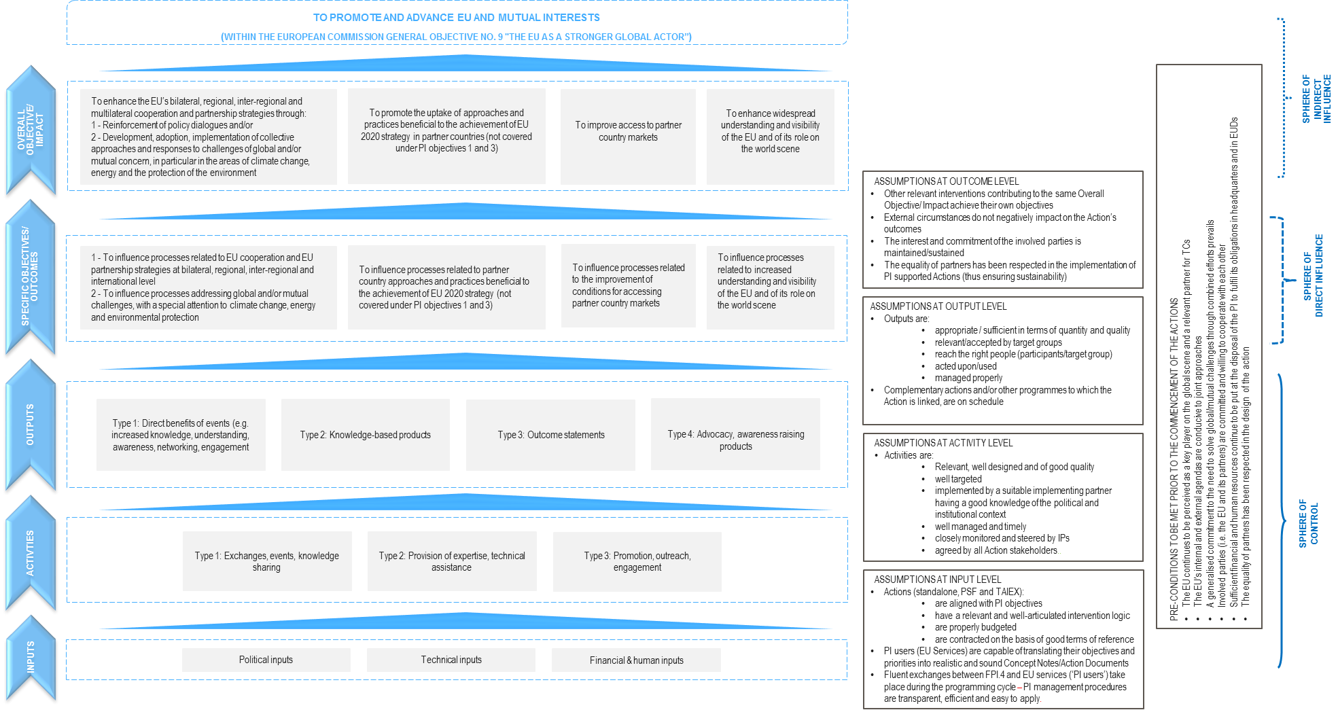

Logframe matrix
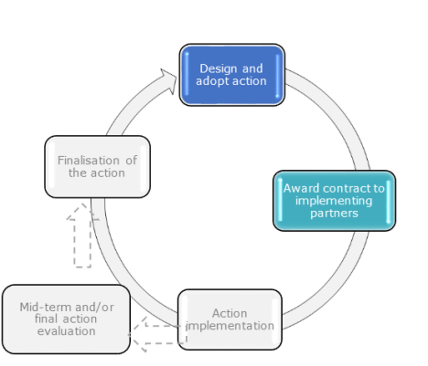
The logframe matrix summarises the key components of an Action’s results chain and details how the results will be tracked and measured.
It indicates where the Action starts from and where it is expected to go. It constitutes a living document that can be updated to reflect on the implementation of the Action.

What is the Logframe Matrix?
The logframe matrix (LFM) is a useful tool to help you develop an action, to ensure that the action has a coherent design and that the action will logically deliver the expected outputs, outcomes and impacts.
The logframe matrix (LFM) presents the following in a single document:
- What results are expected and under what assumptions they will be achieved (Action’s intervention logic), and
- How the Action will be monitored, namely the suite of monitoring indicators selected.
The LFM is a living document, which can be further refined by tenderers / applicants during the procurement stage and is expected to be finalised by the implementing partner, in agreement with the PI project manager, during the starting phase of the Action implementation.
Logframes and implementation modalities

The drafting of a logframe is required for standalone Actions. When you start working on an action in OPSYS, the first step is the creation of an LFM in the system.
For PSF and TAIEX Actions, it is not a formal requirement. However, it is important that the design stage of every Action includes the definition of a clear intervention logic / results chain and the adoption of the relevant monitoring indicators. For PSF and TAIEX Actions, please refer to the separate PSF and TAIEX guidelines.

What results are expected and how will they be achieved?
Designing an Action means conceptualising the process underlying the Action and drafting the blueprint for the way in which the Action should develop.
The starting point of a PI Action is a problem, a need or an opportunity that has been identified, for instance at the level of EEAS or client DGs (e.g. interest from Mexican companies in cooperating on low carbon technologies), but also at the level of EU Delegations (e.g. prospect of a favourable legal and political environment in Mexico) to act at EU level by developing a particular Action.
The rationale for PI funding (the justification that the PI is the most suitable EU instrument to address the problem or to fulfil the need identified at the outset of Action design) also has to be determined at this stage.
Depending on the scope and objectives of the Action envisaged, and the implementation context, a specific type of implementing modality will then be chosen among the three options of stand-alone, PSF and TAIEX Actions.
Distinguishing between standalone, PSF and TAIEX Actions
While all PI implementation modalities are aligned with PI objectives, they are intrinsically different by nature and not all Actions will deliver results at all levels. Standalone Actions would usually be implemented over several years and have far-reaching, long-term goals.
To address the need for quicker Action, the PSF was set up within the PI, to implement Actions of a specific nature which are relatively short. The TAIEX Actions’ lifecycle is also shorter. This should be taken into account in the development of the results chain.
Once you identify the problem/need, generate the rationale for PI funding and select the implementation modality, you then need to begin creating a logframe matrix. The first step is to develop a results chain.

    - Developing a results chain
The first component of the logframe matrix is the results chain of the Action considered.
Results Chain |  | Indicators | Baselines (including reference year) | Targets (including reference year) | Source of verification | Assumptions
Overall Objective - Impact |  |  |  |  |  | Not to be filled-in
Specific Objective(s) - Outcomes
Outputs
Activities
Outlining a results chain is a way to explain the steps that lead to the long-term goal and the connections between Action activities and results throughout (see figure 4). It also details the assumptions that are associated with the steps.
- The process begins with the definition of the Action’s overall objective (e.g. to remove barriers to market access through the definition of compatible ICT standards), what will show how the Action is expected to contribute to the PI’s Objectives (e.g. Countryland to adopt an approach beneficial to the achievement of Europe 2020 strategy). The overall objective “solves” the problem or addresses the need or opportunity defined at the outset of the Action.
- The Action’s specific objective(s) is the intermediate change needed in the light of the overall objective the Action seeks to achieve. In the example provided, the specific objectives of the Action would be (i) to facilitate cooperation and exchange of best practices between the EU and Countryland, and also (ii) to support efforts for an early alignment of EU / Countryland ICT standards. It is important to note that the specific objectives or outcomes are time-bound, they should be set in such a way that they are attainable during the Action lifetime.
- The expected outputs or products resulting from the activities (e.g. identification of fields of mutual interest to pursue cooperation on ICT standards) should be identified. They must be realised / delivered in order to achieve the expected specific objectives and to contribute to overall objectives.
- The activities (e.g. stakeholder workshops and trainings on ICT standards) are defined and planned to generate the expected outputs.
Please note that in OPSYS, there is no activity level in the online template. However, the definition of activities to be implemented remains a very important element of any contract: it should be discussed when an Action is conceptualised. This is why the LFM template here still includes a row for activities, to support the design of the Action.
Implementing partners are required to implement the planned activities: they are reporting on the activities implemented in the progress reports submitted on a regular basis (as defined in specific contracts and agreements) and the PI managers monitor the implementation of activities. For those transitioning from the previous monitoring system to OPSYS, you will also note that the presentation of the “activity indicators” has changed. In OPSYS, they are included in the output indicator list (see the list of indicators in Annex 1).
Figure 4: Results chain

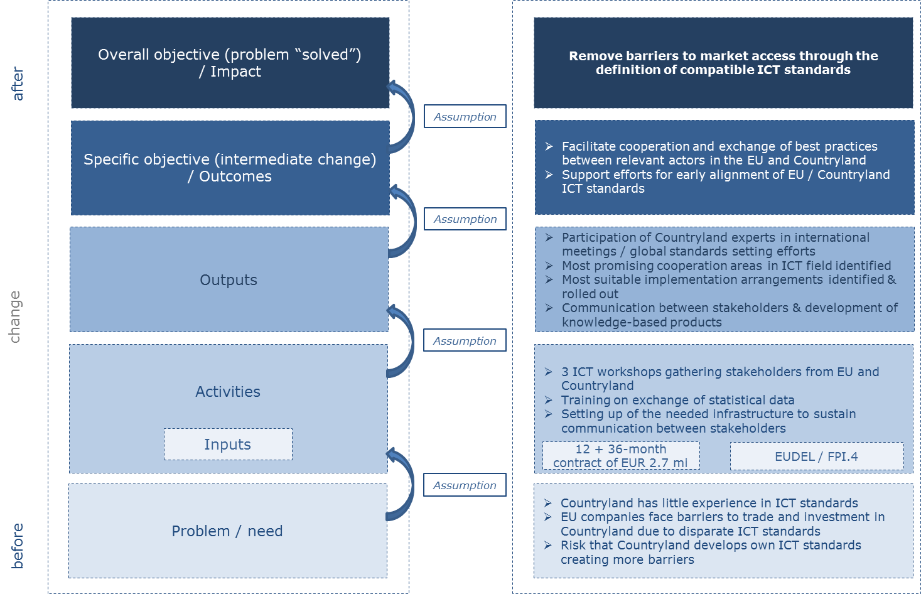

    - Drafting the assumptions
The second element you will fill out in the LFM is the column for the assumptions.

Results Chain |  | Indicators | Baselines (including reference year) | Targets (including reference year) | Source of verification | Assumptions
Overall Objective - Impact |  |  |  |  |  | Not to be filled-in
Specific Objective(s) - Outcomes
Outputs
Activities

When you define the results chain of an Action, at each level, you should state explicitly the assumptions that need to hold true to pass from one level of result chain to the next and to realise the objectives (e.g. The EU and Countryland continue to be interested in cooperation on low emission technologies). As explained in section 4.3 above, assumptions are conditions that must hold true to move from one level of the intervention logic to the next. They stop at outcome level where assumptions are set out to achieve impact – this is the reason why the last cell at the level of overall objective / impact is not to be filled in.
Below is a checklist for the development of an intervention logic (results chain and assumptions) which should help with development and review. It is important to note, the LFM is a living document. It may evolve during an Action timeline. For instance, new activities might be added, and some activities might be replaced or deleted. If an LFM is changed during implementation, it is important to detail the change and document the reason for the change, as well as to make this change approved by the PI project manager.
Checklist for the development of a results chain and assumptions
- Keep it simple. Think of the results chain as a compass, not a map. It is a simplification of how an activity contributes to the expected outputs -> specific objectives -> overall objectives.
- Cover all the relevant elements of the Action. These are activities, outputs, specific objectives and overall objectives.
- Do not make big jumps between the different stages. Levels should logically flow.
- Be realistic about what can be achieved. Do not over-shoot.
- Check whether the Action results chain aligns with the PI Objectives it seeks to contribute to.
- Review the logic. Consider whether the overall objective addresses the problem or need defined at the outset.
- Check the logic of the results chain. This involves verifying whether:
IF we undertake the activities AND the assumptions hold true, THEN we will create the outputs.
IF we deliver the outputs AND the assumptions hold true, THEN we will achieve the specific objective(s).
IF we achieve the outcome(s) AND the assumptions hold true, THEN we will contribute to the overall objective(s).
- Keep revising and improving the results chain. This should be done at every stage of the implementation, using what you have learned in the meantime.

To help you develop the results chain and the assumptions, you may find useful to start filling out an intervention logic template to support the drafting of the Action logframe. Overleaf (figure 5), we present the template with hints and tips for its use.
It is not compulsory to complete an IL diagram. But you will find it helpful before you start working in the LFM template. You will find the intervention logic template in Annex 2.
Remember that when you start working on an Action in OPSYS, you will have to create the LFM for the action. You will be able to export the LFM created in word or pdf.

Figure 5: How to use the intervention logic template
The IL is a theory, therefore it never exactly describes what will happen in the real world. But it makes it logical and clear.

× Do not use the intervention logic for what it is not. It is not a logframe, not a list of indicators, not a strategic plan.

× Do not put too much information in the diagram.

Use plain English.
× Do not try to make the IL perfect, or set it in stone.
Refer to political, technical and / or financial & human Inputs.
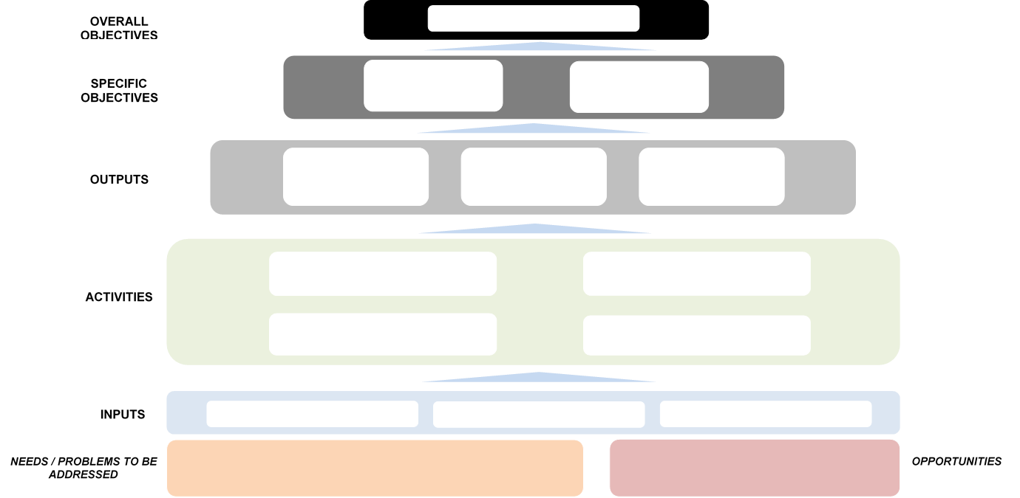

How will the Action be monitored?
The LFM also presents how an Action will be monitored. It does not only summarise the results chain and the underlying assumptions. The matrix should identify the suite of relevant monitoring indicators which correspond to the different levels of the results chain. The selected indicators should be accompanied by baselines and targets (starting and end points) and sources of verification (where the data on indicators will be collected from).
You need to consider all levels of the results chain when defining indicators – though not all Actions will necessarily deliver results at all levels. The chosen indicators should reflect the goals and ambitions of the individual Action considered. There are four steps to define the monitoring framework.
In OPSYS, there are two categories of indicators:
- Core indicators: this is a menu of indicators you can choose from. These indicators capture what EU-funded actions are more commonly delivering.
- Customised indicators: these are indicators you create yourself to monitor what an action is delivering which would otherwise not be captured by the core indicators. You should only use this type of indicators in exceptional circumstances, and seek approval from the FPI of the indicators created.
For those transitioning to OPSYS, please note that the new categories of indicators reflect an effort to simplify the system. It also aims to produce comprehensive data at aggregate level (once monitoring is completed at the level of individual actions, data are aggregated to provide the “big picture” of EU external relations). This is particularly important at outcome and impact level, where the core indicators echo the objectives of EU financing instruments. Using core indicators allows a meaningful aggregation, unlike the creation of new indicators. New indicators cannot be aggregated (because they are so specific).
In principle, monitoring will be based on the core indicators (as a rule), or completely new indicators created for a specific action (as an exception). When you create a new indicator, you will have the possibility to match it to a core indicator. For more information on the selection and creation of indicators, please refer to the OPSYS guidelines.
- Select or develop relevant indicators
Tip! When you think about indicators, first look at the list of core PI indicators. This is a menu you can choose from to monitor Actions.
Indicators are variables that can be measured in order to provide information to monitor the progress and achievements of the Action over time. There must be at least one indicator for each element of the results chain.
- Define the baseline for each indicator
A baseline is the starting point of an Action. Depending on the indicator, a baseline can be
- quantitative (you report a number, percentage) or
- quantitative and qualitative (you report a number, percentage and a narrative providing background / context information).
In the PIMS, baselines are zero (0) by definition. It does not mean that nothing was happening before an action was launched, it means that it is the starting point for this action. Remember that a baseline is often completed by a qualitative narrative. The narrative provides contextual information, explains the situation in which an action will be implemented. In turn, that will also help us to assess what results are delivered at the end of the action.
There might be an exception to setting the baseline at 0: when an action is implemented through successive phases. For the second phase of the action, baselines can be positive, to build on what has been achieved by the first phase of the action.
- Set the target for each indicator
For each indicator, you also need to set a target, which gives the expected end point for the Action. Targets should be challenging but not unrealistic. They should be refined and finalised through discussions between the implementing partners and the project manager. Targets can be revised, if necessary, by agreement between all partners.
Over the lifetime of an Action, you can also define milestones. They are reference points to check the progress made towards a desired target. Milestones can be often described as interim targets, which allow you to periodically check if an Action is on track or not.
Remember, when you set targets, it is very important to carefully define what you will monitor. Make sure the Action stakeholders have the same understanding of the “process”, “approach” or “practice” (for instance) that the action aims to influence.

Remember: Don’t confuse outcomes, baselines & targets, and indicators

For example, if the desired outcome is “increased market opportunities for EU companies in Mexico”:

Relevant indicator | Possible baseline | Possible target
Number of EU companies in sector X exporting newly to Mexican market | The baseline is 0 in 2017 as only companies newly entering since the start of Action implementation are being counted (it is possible to complement this by a qualitative narrative specifying the presence of 75 EU companies in the Mexican market so that further counting is eased) | 150 EU companies newly entering the Mexican market by 2020

- Identify the source of verification
The final step in the LFM is to identify the source of verification for each indicator. It explains where the data for measuring / tracking an indicator will be found. It is essential to identify the source of verification while an indicator is being selected because an indicator without a source of verification is of no use. If it is not possible to collect data relating to an indicator, then another indicator will have to be found.
Make sure not to confuse “target” and “source of verification”. For instance, if the action you implement aims to influence the country X’s position ahead of the COP15 on the Convention on biodiversity, you will likely consult the documents issued by country X which describes the country’s position on the Convention on biodiversity. If the action influences country X’s position, you will report one (1) outcome. You will not report on the total number of documents you review.
The figure on the next page helps you to fill out the LFM. You will find the logframe matrix in Annex 3: Logframe Matrix.

Figure 6: How to fill out the monitoring information in the LFM?
Define a target for each indicator, including the reference year
×Don’t choose an indicator without identifying a source of verification
Baselines are action-specific
Define a baseline for any indicator, including the reference year
There must be at least one indicator for each element of the results chain, including activities

Results chain |  | Indicator | Baseline | Target | Source of verification | Assumptions
Overall objective / impact |  |  |  |  |  | Not to be filled in
Specific objective(s) / outcomes

Outputs

Activities

The template includes an activity row to support the design of the action (where relevant).
In OPSYS, you will not find “activities” anymore because the platform is focused on results.

×Don’t include in the indicator any words referring to the desired direction of change.
For example instead of ‘Increased number of’, just use: ‘Number of’
Ensure the source of verification is realistic and not disproportionately burdensome
Identify existing source of verification where possible to make data collection more manageable

This logframe gives an example of how you could fill out the template:

Results Chain |  | Indicators | Baselines (including reference year) | Targets (including reference year) | Source of verification | Assumptions
Overall Objective - Impact | To improve conditions for investment in low carbon technologies in Countryland | Number of barriers to market access, investment and business development which have been removed | 0  Distortionary subsidies exist in Countryland which favour national economic operators introduce asymmetry in market access | 1  Removal of one subsidy to national operators supporting the development of low carbon technologies | - Published legislation, regulatory information or industry norms  - Relevant (sectoral) studies or surveys (e.g. market surveys, technology studies, etc.)  - Documentation of relevant market data (e.g. market prices, tariffs, rules) | Not to be filled-in
Specific Objective(s) / Outcomes | To support stakeholders engagement on low carbon technologies | Percentage of participants targeted by the joint public relations campaign who acknowledge having engaged further on the topic on their own initiative as a result of their participation in the campaign
Outputs | Awareness raised & better understanding of Countryland stakeholders on low carbon technologies and opportunities for collaboration with EU businesses | Number of non-EU companies that participated in the events organised
Activities

To summarise:
Step | PI project manager / PI user | Implementing partner
Draft the logframe during early planning phase
Develop the logframe during tender phase
Finalise the logframe during the inception phase, including final choice of indicators, definition of baselines, targets and sources of verification
Validate the choice of indicators, the definition of baselines, targets and sources of verification
Detail in your inception report your data collection strategy in line with the monitoring planned
Quality review the choices made by the implementation partner and ensure that they are reflected in the data collection strategy for the Action

See also section 6 for more information on indicators and section 7 on data collection.
Remember: It is important to note that the LFM is a living document, and that it may evolve throughout the lifetime of an Action. For instance, new activities might be added, others replaced or deleted. If an LFM is changed during implementation, it is important to detail the change and document the reason for the change. Don’t forget to agree any change to the LFM with the PI project manager! Some of the more substantial changes might require the signature of a rider.
Also remember that OPSYS, the online platform, is live. The different functionalities (project design / LFM, monitoring and reporting, etc.) are being rolled out progressively. In the future, you will complete all of the steps described here in OPSYS. Check the updates and the OPSYS guidelines.

Indicators
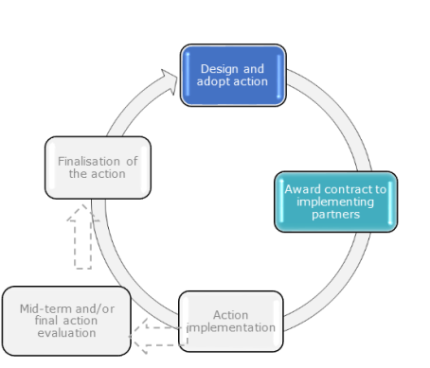

The selection and development of indicators is an essential component of the monitoring of any Action. The process starts by reviewing the list of (pre-defined) PI core indicators, which provide a common base for the monitoring of PI Actions. In exceptional cases, you may also consider creating customised indicators to capture the specific needs of an Action.

What are indicators?
Indicators are quantifiable or qualitative variables that can be observed in order to provide information on the performance / progress of an Action against the expected results over time. Indicators should be used for each level of the intervention logic:
Output indicators | Provide a measure of the direct products that the planned activities are expected to generate.  e.g.: number of events organised, number of participants in an event, number of communication products developed
Outcome indicators | Measure the direct effects on the political, social, economic or environmental area targeted by a PI Action as well as changes in perception, behaviour or engagement of its participants/ target groups. These effects are expected to materialise within the lifetime of the Action and are under its direct influence.  e.g.: number of processes related to partner country approaches to challenges of global concern which have been influenced; number of processes related to partner country practices on trade, investment and business which have been influenced
Impact indicators | Measure the degree to which an Action has contributed to its overall objective.  e.g.: number of barriers to market access, investment and business development which have been removed; number of EU bilateral partnership strategies which have been enhanced

Action design and monitoring are interdependent. The Action’s overall and specific objectives and planned outputs and activities should be clearly stated so that it is possible to identify indicators to measure progress and achievements.
There exist quantitative indicators which indicate a quantity (e.g. a number or percentage) and qualitative indicators which depict a situation / status in qualitative terms. Neither type of indicator is better than the other; their usefulness will depend on the context and the result to be measured. Often, monitoring will rely on a mix of quantitative and qualitative indicators which give a fuller picture of the results achieved. A combined use of quantitative and qualitative indicators also allows for triangulation, namely it will help you draw on information from different sources and perspectives, strengthening the quality of the information you will present.

PI core outcome and impact indicators combine quantitative and qualitative measurement to capture the full picture of the results of the Action. For instance, even if an indicator is quantitative (e.g. number of processes related to non-state level partnership / agreements which have been influenced), you are required to complement the quantitative information with a qualitative narrative explaining how the numbers were arrived at. In particular, for outcome and impact indicators, it will not always be possible to conclude on the direct causality between an Action and observed results. A number of external factors are likely to come into play. The monitoring should uncover a degree of correlation or contribution of the Action to the observed change. The narrative will then help capture other elements relevant for a better understanding and evaluation of an Action (for example, a change in the government of Countryland willing to engage with the EU or an Action by another actor running in parallel to the EU’s Action and reinforcing its impact).

When to select and develop indicators
The selection and development of indicators is important because it frames the data collection which will be ongoing throughout the implementation of the Action. The selection of indicators starts early in the Action cycle:
- During the preparation of the Concept Note, the PI users and FPI project managers propose the Overall Objective, Specific Objectives, Outputs and Assumptions underpinning the planned Action. They prepare the LFM in OPSYS.
- The Quality Support Group approves the Action Fiche (this step is internal to the European Commission). This approval triggers a number of steps for the preparation of the Commission decision (the proposal should get clearance from the Cabinet, it is then submitted to inter-service consultation before it is approved by the PI committee and adopted as a Commission decision)
- Then the procurement phase starts. This means that a number of elements are added to the LFM at this point: (1) monitoring indicators together with their sources of verification (for data collection), (2) baselines and targets for each indicator, and (3) activities where relevant. Please note that the description of the activities is included in the tendering documents but not in OPSYS.
- During the procurement procedure, the PIMS guidance is made available to the tenderers / applicants so that they familiarise themselves with the monitoring and reporting requirements. They are expected to further elaborate the draft logframe matrix as part of their tender / proposal.
- At the start of the Action, the implementing partners finalise the LFM (in particular the set of indicators and data collection plan) in consultation with the PI project manager.
- During implementation, if necessary, changes can be made to the choice of indicators (or the target values) subject to the approval of the responsible PI project manager.

It is critical that stakeholders agree the selection of indicators and have a shared understanding of the indicators.
Please note that over time, all these steps will be implemented in OPSYS, from the creation of the LFM to the closing of the Action. It will be a collaborative exercise between the PI manager and the implementing partners.

How to choose indicators?
The PIMS gives you the possibility to choose between different categories of indicators:
- PI core indicators are a set menu of standard indicators, defined in relatively general terms to capture results of the PI Actions (more detail is provided below). They are consistent with the PI objectives and allow to show progress made, at aggregate level, towards achieving the PI objectives.
- Customised indicators are Action-specific indicators, developed by PI project managers / PI Users and implementing partners that aim to capture results which core indicators do not. They should be used only when core indicators are not sufficient to monitor progress and their usage will remain limited to exceptional circumstances.
Figure 7: How to choose or develop the relevant indicators?

No, the Action is so specific that the indicators don’t capture what it is doing
Are the core indicators relevant for the Action considered?
Yes
And/or

You develop new indicator(s)
You are using core indicators

You are using customised indicators

PI Core indicators
The (pre-defined) PI core indicators are consistent with the PI objectives. The use of PI core indicators makes it possible to aggregate results of all individual Actions funded by the PI. In turn, thisallows to show progress, at aggregate level, towards the PI objectives. Aggregation will be particularly important at outcome and impact level, where the results are expected to contribute to the policy objectives of the PI. As a consequence, PI stakeholders should seek to use PI core indicators, especially at outcome and impact level - customised indicators will be more an exception.
The list of 30 core indicators is comprehensive, covering all stages of the results chain (activities, outputs, outcomes and impact) of the PI Actions, the different areas in which the PI is deployed, and should be flexible enough to respond to the specific nature of Actions. The reason for developing the list of core indicators is so that the PIMS will have a consistent set of indicators to build on. It is also for ease of selection for all stakeholders when developing their LFM.
The following section offers further description of core indicators and is broken down by activity, output, outcome and impact.
It is important that when you select the monitoring indicators for an Action, you avoid double counting. Make sure you don’t count the same thing twice.
The full list of PI core indicators, with unit of measurement and disaggregation can be found in List of indicators, unit of measurement and disaggregation (Annex 1).

    - Activity Indicators
There are no core activity indicators on OPSYS. Progress on the implementation of the planned activities is presented in the progress reports, submitted on a regular basis to PI managers as provided for in the specific contracts.
For stakeholders transitioning to OPSYS, please note the following:
- Indicators previously known as A1 (number of events organised/supported) and A3 (number of communication campaigns designed and implemented) can now be found in the list of core output indicators
- If you were using the activity indicator A2 (number of person days of technical assistance or expertise provided), you are expected to keep reporting on this indicator in the narrative report you prepare for the PI project manager.

    - Core Output Indicators
To routinely monitor the direct products of activities brought about by PI Actions (as defined in the PI intervention logic) there are eleven core output (OP) indicators. They are quantitative indicators, some of them to be complemented by a qualitative narrative to help put the results achieved in perspective.
The definition of the PI core output indicators and examples for use can be found in Output (Annex 1).
Title | Unit of measurement | Disaggregation
Number of events organised or supported | Number  Narrative description of the topics | By type of event:  - Visits, exchanges, study tours  - Business missions  - Technical meetings (to discuss a specific technical subject)  - Group events (conferences, debates, workshops, seminars)  - Training  - Outreach and advocacy (including networking events, cultural collaboration activities)
Number of participants in the events organised/supported | Number | By gender  By sector of participants  - Academia and students  - Government  - Business/private sector  - Media  - Civil society  - Other  By type of event  - Visits, exchanges, study tours  - Business missions  - Technical meetings  - Group events  - Training  - Outreach and advocacy
Percentage of participants in the events who report having benefited from the events organised/supported | Percentage | By gender
Number of EU companies that participated in the events organised/supported | Number  Narrative description of business focus of the participating companies | By type of event  - Business missions  - Group events  - Trainings
Percentage of EU companies which report having benefited from the events organised/supported | Percentage | By type of event  - Business missions  - Group events  - Trainings
Number of non-EU companies that participated in the events organised/supported | Number  Narrative description of business focus of the participating companies | By type of event  - Business missions  - Group events  - Trainings
Percentage of non-EU companies which report having benefited from the events organised/supported | Percentage | By type of event  - Business missions  - Group events  - Trainings
Number of outcome statements emanating from the events | Number  Narrative description of the subject(s) covered by the official statement(s) | n/a
Number of knowledge-based products developed | Number  Narrative description of product type (e.g. study, report, publication, assessment, database, roadmap, guidelines, etc.)  Narrative description of the subject covered (e.g. climate change, trade barriers, migration, etc.) | n/a
Number of communication products developed | Number  Narrative description of communication product (e.g. article, opinion piece, press release, video interview, leaflet, etc.)  Narrative description of the subject covered (e.g. climate change, trade barriers, migration, etc.) | n/a
Number of public/media/communication campaigns designed and implemented | Number  Narrative description of the topic | n/a

Don’t forget to select only the most relevant OP indicators not to double count outputs.

NB! Under the indicator “number of public/media/communication campaigns designed and implemented”, the word “campaign” is used in its broadest sense. It is an activity under which different communication products are developed (see core output indicator “number of communication products developed”, for instance websites, leaflets, posters, etc.). Sometimes, a campaign will be composed of different activities and will run for a substantial amount of time if not the whole duration of an Action. At other times, a campaign will be more focused and implemented only at a particular point in time.

To report on event participation, consider the type of events you organise/support:

  - If you organise a closed event, use the registration process to gather information on the participants. Remember that you will not only report on the number of participants but should also gather information on the participants (gender breakdown and background).

Tip! Use the reporting template and mirror the template in your registration process. Include the necessary details in the registration form so that you systematically collect all the details at once.

  - If you organise an open event (where participants are not registered), you will be able to report on an estimated number of participants and an estimated gender breakdown. For instance, have a member of your team count the number of participants at the gate for 30 minutes / 1 hour (depending on how long the event is) and the number of F/G & M/B. You create a sample of the participation – you can do it also twice during a day event for instance, to have a more representative sample. You can then extrapolate on the total number of participants and the gender breakdown.

    - Core Outcome Indicators
The Action’s specific objectives / outcomes are critical elements of the results chain. Outcomes are about changing the perception, behaviour or engagement of the target groups. Compared to outputs, they materialise later and are not under the full control of the implementing partner. They are supposed to be achieved within the lifespan of the Action considered. The fourteen (14) core outcome (OC) indicators focus mainly on processes the PI aims to influence. Remember that each Action will probably be about one particular process or change in perception / behaviour / engagement to which different activities contribute. For example, if an Action organises a series of stakeholder workshops on ICT standards, each of the workshops will be counted separately against an output indicator and contribute to influencing one process on a partner country approach beneficial to the achievement of the Europe 2020 strategy.
The definition of the PI core outcome indicators and examples for use can be found in Outcome (Annex 1).
Title | Unit of measurement | Disaggregation
General
Number of processes related to state-level and sub-state level (bilateral, regional, multi-lateral) partnership strategies and policy dialogues which have been influenced | Number and narrative.  The narrative specifies the type of process being influenced and the subject of the process (for example “developing a strategic partnership on urbanisation”). It provides a narrative explanation of how the processes have been influenced in line with the objectives of the Action to justify the quantitative value reported. | n/a
Number of processes related to non-state level partnerships / agreements which have been influenced. | Number and narrative.  The narrative specifies the type of process being influenced and the subject of the process (for example “developing the Covenant of Mayors”). It provides a narrative explanation of how the processes have been influenced in line with the objectives of the Action to justify the quantitative value reported. | n/a
Number of processes related to partner country approaches to challenges of global concern which have been influenced. | Number and narrative.  The narrative specifies the type of process being influenced and the subject of the process (for example “processes related to emission standards”). It provides a narrative explanation of how the processes have been influenced in line with the objectives of the Action to justify the quantitative value reported. | n/a
Number of processes related to partner country practices on challenges of global concern which have been influenced | Number and narrative.  The narrative specifies the type of process being influenced and the subject of the process (for example “assisting with the drafting of low carbon legislation” or “bringing emissions standards in line with EU interests”). It provides a narrative explanation of how the processes have been influenced in line with the objectives of the Action to justify the quantitative value reported. | n/a
Number of processes related to the positions partner countries take in the run-up , or during, regional/ international fora which have been influenced | Number and narrative.  The narrative specifies the type of process being influenced and the subject of the process (for example “influencing the position to be taken at the UN Conference on Climate Change”). It provides a narrative explanation of how the processes have been influenced in line with the objectives of the Action to justify the quantitative value reported. | n/a
Number of processes related to partner country approaches beneficial to the achievement of the Europe 2020 strategy which have been influenced. | Number and narrative.  The narrative specifies the type of process being influenced and the subject of the process (for example “enhancing the processes related to dialogue on human rights”). It provides a narrative explanation of how the processes have been influenced in line with the objectives of the Action to justify the quantitative value reported. | n/a
Number of processes related to partner country practices beneficial to the achievement of Europe 2020 strategy which have been influenced. | Number and narrative.  The narrative specifies the type of process being influenced and the subject of the process (for example “influencing a stronger application of child labour laws” or “amending legislation regarding the treatment of illegal migrants). It provides a narrative explanation of how the processes have been influenced in line with the objectives of the Action to justify the quantitative value reported. | n/a
Trade
Number of processes related to partner country practices on trade, investment and business which have been influenced. | Number and narrative.  The narrative specifies the type of process being influenced and the subject of the process (for example “developing legislation on trade in green goods”). It provides a narrative explanation of how the processes have been influenced in line with the objectives of the Action to justify the quantitative value reported. | n/a
Number of processes related to the removal of barriers to market access, investment and business which have been influenced. | Number and narrative.  The narrative specifies the type of process being influenced and the subject of the process (for example “removal of barriers to trade in renewables”). It provides a narrative explanation of how the processes have been influenced in line with the objectives of the Action to justify the quantitative value reported. | n/a
Number of processes related to the negotiation, implementation or enforcement of EU trade and investment agreements with partner countries which have been influenced | Number and narrative.  The narrative specifies the type of process being influenced and the subject of the process (for example “removal of restrictions on foreign direct investment”). It provides a narrative explanation of how the processes have been influenced in line with the objectives of the Action to justify the quantitative value reported. | n/a
Percentage of EU companies’ which acknowledge a positive change in their perceptions of the business, trade and investment climate in partner countries | Percentage | n/a
Advocacy
Percentage of participants targeted by outreach and advocacy events who acknowledge a positive change in their perception of the EU and/or international policies and standards | Percentage | By gender
Percentage of participants targeted by outreach and advocacy events who acknowledge having engaged further on the topic on their own initiative as a result of their exposure to an event | Percentage | By gender
Number of articles published in print and/or digital media about an event | Number  Narrative description of the tone (positive, neutral - factual, negative) of the article(s)  Narrative description of the subject(s) covered by the article(s)  Name of the print and/or digital media | n/a

As seen above, most core outcome indicators request information on the number of processes which have been influenced by an Action. Measuring influence is challenging and it is important to collect the relevant information / evidence that justify that the Action has influenced a process. A number on its own is not sufficient to measure the achievement.
In fact, additional details need to be provided in the form of a narrative description to explain what process was influenced, how and to what extent the Action has influenced the process. You should also describe the evidence that made you conclude that a process had been influenced. The narrative description is required in both the current reporting template and in OPSYS.
 | Example
Process and the subject of the process | Influencing the development of regulatory standards by a partner (e.g. how India is approaching the development of ICT standards)
How the process(es) have been influenced by the Action | The PI-Action in India on ICT standards has led the Government of India to commit to and actively engage in regulatory cooperation efforts. The relevant evidence includes the regular dialogue between the EU, India and ICT stakeholders on regulatory issues, the commitment by both partners to cooperation with the identification of topics of mutual interests and the definition by India of an implementation strategy for the use of certain international standards, and India’s participation in international standardisation fora to support its own developments.

The final four outcome indicators in the list deal with perceptions, engagement and media coverage (related to the perceptions of the business environment, to the perception of the EU in general, engagement on certain topics and media coverage). They might be relevant in particular for EUPOPs and public diplomacy actions. Perception and engagement measuring may require a phased approach to surveying the target groups. The data collection strategy should plan for the need to collect participants' feedback immediately after the event took place (to report at output level) and after an appropriate period of time to monitor the longer-term changes (against core outcome indicators). It is important that your data collection accounts for these considerations (e.g. necessity to keep contact details of participants) and the resources for monitoring ear-marked accordingly (see section 7 for more information).
To avoid double-counting and select the most appropriate indicator(s), a number of distinctions are made in the wording of the outcome indicators. To select the appropriate indicators, ask yourself the following questions:
Is the Action about…
…the EU and Countryland partnership? |  | …or is it about the situation in Countryland?
To what extent has the Action had an influence?
Does the Action influence Countryland’s approach to e.g. climate change (what the country says it will do or would like to do, in terms of readiness to negotiate an international agreement for instance)? |  | Does it influence Countryland’s practices on climate change (what the country actually does, in terms of adopting energy efficient technologies for instance)?
Does the Action relate to Europe 2020?
Yes, it explicitly relates to Europe 2020 and PI objective 2 |  | - No, it does not relate to Europe 2020
Is the Action trade- or advocacy-specific?
Yes, it is trade-specific | Yes, it is advocacy-specific |  | No
    - Core Impact Indicators
As noted above, the overall objective / impact of each Action should be contributing to at least one of the four objectives of the PI. These objectives are:
To enhance the EU’s bilateral, regional, inter-regional and multilateral cooperation and partnership strategies through:  - Reinforcement of policy dialogues and/or  - Development, adoption, implementation of collective approaches and responses to challenges of global and/or mutual concern, in particular in the areas of climate change, energy and the protection of the environment | E.g. An official dialogue in the field of energy efficiency and green transition has been established between the EU and Countryland; The collective approach developed by non-governmental stakeholders in the area of climate change has led the Government of Countryland to revise its strategy for COP21
To promote the uptake of approaches and practices beneficial to the achievement of EU2020 Strategy in partner countries (not covered under Objectives 1 and 3) | E.g. An official dialogue has been established on mobility and legal migration; A technical barrier to the trade in cheese between the EU and Countryland has been removed by Countryland
To improve the conditions for accessing partner country markets | E.g. A partnership has been established in the domain of civil aviation between the EU and Countryland
To enhance and widen the understanding and visibility of the EU and its role on the world scene | E.g. Leaders in Countryland recognise the EU as a foreign policy actor; The general public in Countryland is aware of the cultural creativity and diversity of the EU
The impact of an Action is the medium to long-term result of the Action. The impact addresses the problem / need / opportunity identified at the outset of the Action. Any Action’s impact is also affected by other external factors apart from the Action. In some cases, the impact can materialise by the end of Action implementation. In many cases though, the impact is likely to be achieved after an Action is completed. In such cases, it will be important to gather any evidence of the progress made already towards the overall objective / expected impact and report on prospects towards reaching the impact. Even if it will in general not be possible to observe an actual impact, a qualitative narrative is required to provide a description of the progress made.
There are five core impact (IMP) indicators. Their definitions can be found in Impact (Annex 1). There is no disaggregated information required at impact level.
Title | Unit of measurement | Disaggregation
Number of EU bilateral, regional, inter-regional and multi-lateral cooperation partnership strategies which have been enhanced | Number and narrative.  The narrative specifies the partnership strategy being enhanced (such as EU-[country] framework agreement or EU-[country] strategic partnership) and provides a narrative explanation of how the strategy has been enhanced in line with the objectives of the Action to justify the quantitative value reported. | n/a
Number of collective approaches and/or practices to challenges of global and/or mutual concern which have been developed/adopted/implemented | Number and narrative.  The narrative specifies the challenges being addressed jointly by the EU and the partner country in global and/or their mutual interest (e.g. adoption of binding methane emissions reduction targets) and provides a narrative explanation of how the approaches and/or practices have been developed/adopted/implemented in line with the objectives of the Action to justify the quantitative value reported. | n/a
Number of approaches and/or practices beneficial to the achievement of the EU2020 strategy which have been taken up in partner countries | Number and narrative.  The narrative specifies the strategy being influenced in the partner country and beneficial to the EU (such as the development by a partner country of an approach towards illegal migration) and provides a narrative explanation of how the strategy has been influenced in line with the objectives of the Action to justify the quantitative value reported. | n/a
Number of regulations and standards relating to trade, investment and business in partner countries which have been aligned to EU / international standards | Number and narrative.  The narrative specifies the regulations and standards which have been aligned to EU / international standards and provides a narrative explanation of how the alignment has been achieved in line with the objectives of the Action to justify the quantitative value reported. | n/a
Number of barriers to market access, investment and business development which have been removed | Number and narrative.  The narrative specifies which barriers have been removed and provides a narrative explanation of how it was made possible in line with the objectives of the Action to justify the quantitative value reported. | n/a

It is important to consider the following elements when selecting the relevant impact indicators to avoid double counting:
When you decide between … don’t forget that…
How to choose between the 2nd and 3rd core impact indicator? | The 2nd core impact indicator reflects the existence of a mutual interest of the EU and the partner country concerned or a global interest while the 3rd indicator reflects an approach / practice of a partner country beneficial to the attainment of EU2020 strategy.  The 3rd core impact indicator specifically deals with EU2020 dimensions not linked to global challenges (2nd indicator) or trade (see below 4th and 5th indicators)
How to choose between the 4th and 5th core impact indicator? | They are trade-specific impact indicators.  The 4th indicator is specifically about alignment of regulations and standards (which can constitute barriers to trade, investment and business) while the 5th indicator is about any other types of barriers to market access, investment and business

Customised Indicators
Please note that you should only use this indicator category in exceptional circumstances. If you create a customised indicator, you should seek approval of the indicator from the FPI.
    - Why using customised indicators?
In this section, we review why and how to customise indicators.
The creation of new indicators aims to monitor what cannot be monitored using core indicators. There might be an exceptional situation where a PI Action achieves something very specific that cannot be monitored by a PI core indicator. In this case, you will create a “customised” indicator.
It is important to note that the different categories of indicators (core and customised indicators) are not mutually exclusive. To ensure that all aspects of an Action are monitored appropriately, you might use a mix of different types of indicators.
When you develop a new indicator, please follow the OPSYS guidelines. It will help you define the key features of the new indicators and set out guidelines on how to use these indicators. This is necessary to ensure a shared understanding of the indicators for the Action. Remember to also seek approval of the customised indicators from the FPI’s OPSYS focal point.

    - How to develop customised indicators?
Customised indicators are first developed at design stage, refined or added in a tender / application and / or finalised at the start / during the inception of Action implementation. That will ensure that the finalisation of the monitoring framework matches the specifics of the Action. The implementing partners are responsible for the finalisation of the customised indicators to ensure their ownership – either matched to core indicators or non-matched – which will be validated by PMs.
The quality standards for the development of indicators, and the methodology to gather the evidence on any indicators, are set by the European Commission in the Better Regulation Guidelines. Indicators / methodologies should be RACER. RACER is an acronym and broken down below:
RACER
Relevant: relates / measures only the design element which is intended for measurement and not any other elements
- Does it relate to the expected objectives?
- Is it measuring the right thing?
- Does it allow for measurement between the current situation and the target(s)?
- Is it specific and does it include guidance for monitoring?

If you implement an Action which consists of a series of workshops targeting EU and Countryland industries on low emission technology, what could be the monitoring indicators?
Number of processes related to non-state level partnership on low emission technology  - Relevant because it focuses on one of the key objectives and on the relevant stakeholder groups | Number of processes related to Countryland practices on climate change  - Not relevant because it does not measure the right thing: the Action targets the industry and not a state-level process
RACER
Accepted: accepted by all stakeholders (project managers and implementing partners – especially since the latter are responsible for reporting back on indicators)
- Is the meaning understood and accepted?
- Is the rationale behind the choice of the indicator understood and accepted?

OC-indicator: Number of processes related to developing industry-level partnerships between the EU and Countryland which have been influenced  - Accepted because it focuses on the non-state level processes | OC-indicator: Number of processes related to developing a strategic partnership on low emission technology with Countryland which have been influenced  - Not accepted because this refers to state-level processes, which go beyond the matchmaking sessions
RACER
Credible: a measure of the targeted issue which is unambiguous and easy to interpret
- Is the indicator clear and not ambiguous in its language?
- Is the data transparent and easy to interpret?
- Will stakeholders be clear on what is being measured?

A-indicator: Number of matchmaking sessions between the EU’s and Countryland industries on low emission technology organised  - Credible because very clearly worded | A-indicator: Successful match-making sessions between the EU’s and Countryland industries on low emission technology  - Not credible because the wording of the indicator is subjective, it already talks about the expected direction of the activities
RACER
Easy: to track, to make sure information can be collected
- Is the indicator easy to measure through the life of the Action?
- Is the necessary data easily available or is it expensive to collect?
- Is the data collected easy to analyse?

OC-indicator: Percentage of EU companies which acknowledge a positive change in their perceptions of the business climate on low emission technology in Countryland after each matchmaking session  - Easy because the data will be collected at regular intervals, using the same methodology (e.g. satisfaction survey to be filled out by matchmaking sessions participants) and easy to analyse | OC-indicator: Percentage of EU companies which acknowledge a positive change in their perceptions of the business climate on low emission technology in Countryland three years after the matchmaking sessions were organised  - Not easy because it creates a high cost for the implementing partners a long time after their contract has come to an end
RACER
Robust: as valid measure of the targeted issue, as objective as possible, well explained and documented, not subject to manipulation
- Does it use data of sufficient quality? Can others come to the same conclusion based on the data?
- Does the use of the indicator avoid double counting?
- Is it consistent in its units of measurement?
- Is it reliable in terms of its accuracy, repeatability and the clear specification of protocol and formulas used in the calculations?

OP indicator: Percentage of EU companies which report having benefited from each matchmaking session  - Robust if the data is collected at regular intervals, using the same methodology (e.g. satisfaction survey to be filled out by matchmaking sessions participants) | OP indicator: Percentage of EU companies which report having benefited from each matchmaking session  - Not robust if the participants in matchmaking sessions are not systematically surveyed and if the satisfaction survey does not remain the same throughout the Action

How to use indicators?
Monitoring is based on the comparison of the achieved progress / results to the planned values. For each indicator, remember to systematically define a baseline and a target:
- Baseline or starting point of the Action: what is the context / situation the Action seeks to address?
- Target or end point of the Action: where is the Action expected to go?
Baselines and targets will be of either quantitative or qualitative nature. They can also combine both as is the case for majority of PI core outcome (PI SO.01 to PI SO.10) and all impact indicators. For the latter case, where a number alone (e.g. number of processes related to state-level partnership strategies influenced) does not allow for a meaningful evaluation of an Action’s performance, the accompanying narrative to be developed will explain where the Action started from and what it achieved. It will also help qualify the progress made and justify the reported quantitative value. For instance, for a baseline this narrative will state the topic- / country-specific context, will describe difficulties to engage with Countryland at state level on a certain topic in the past or any pre-existing dialogue.

Checklist for a good set of indicators
- Have you selected indicators to cover the whole results chain of the Action considered?
- Are you aware of the level of disaggregation needed for a particular indicator you’ve selected?
- Have you customised indicators where necessary?
- Are your indicators a mix of number-based (i.e. quantitative) and descriptive (i.e. qualitative) ones that allow for triangulation (i.e. draw on information from different sources and perspectives)?
- Are your indicators RACER?
- Have you made sure that each indicator is accompanied by a baseline and a target?
- Are your indicators neutral statements (such as level of, number of) that do not assume change (e.g. an increase – which should instead be described in target)?
- Are your indicators realistic and relevant to your ability to measure, monitor and evaluate change?

Data collection strategy

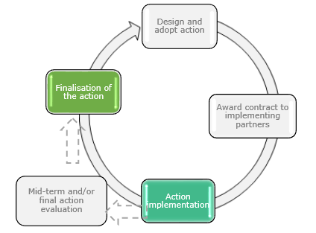
A well-thought through data collection strategy will allow you to collect & manage monitoring data as a part of your Action implementation.
Data will be collected by the implementing partners.

Planning data collection and analysis
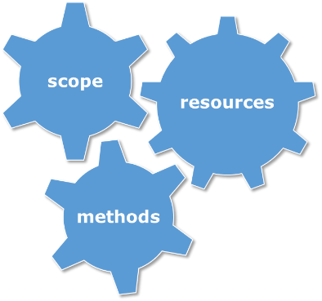
Before deciding on the methods to be used for data collection, it is very important to make the purpose of data collection clear. This means making sure everyone knows what indicators the data is required for; what data items need to be collected, etc. In order to report on the indicators, particularly the core indicators, it is extremely important that the data is useful and clear.
A useful tool for helping you summarise your data collection strategy is the logframe matrix. The LFM allows you to structure your ideas about the subject (about who or what you will be collecting data on), means of verification (where this data will be found) and frequency of data collection (how often it will be collected).
Once the purpose and scope of data collection are defined, you will select the most appropriate data collection tools taking into consideration the financial and human resources available (you should determine what share of the Action budget is dedicated to monitoring, as well as confirming that your team has the competency to use the data collection tools chosen).
Setting up your data collection strategy is an important element of the thinking around the implementation of any action. If you anticipate on data collection needs, you can build it into your implementation choices. For instance, if you have to provide data on participants in an event disaggregated by sector of participants, you might consider setting up a registration process using an online platform. This will allow you to collect data on the participants, before an event takes place (as it might be more challenging to engage with the participants once the event has taken place) and at a relatively low cost. You will then be able to check against the list of participants and report on who has actually attended the event while providing a description of the sector of the participants.
Planning data collection is a back and forth process whereby you refine your data collection strategy, to ensure it is purposeful, while making sure that the necessary resources are available and ear-marked for data collection.
The responsibilities for data collection are split as follows:
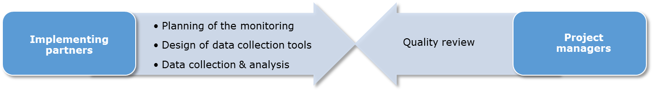

TIP: Don’t be too ambitious in your data collection strategy. Choose data collection methods for which you have the people and resources.
5-step checklist for the drafting of a data collection strategy
STEP 1: MAKE THE PURPOSE CLEAR
- Identify the indicators that you require data for
- List the data items you need to collect
- Make sure the data is useful NOT just interesting
STEP 2: DEFINE THE SCOPE OF DATA COLLECTION
- List the characteristics that define who or what about you will be collecting data (subject)
- List the characteristics that define where this data will be collected (location)
- List the characteristics that define when this data will be collected (time and frequency)
STEP 3: DEVELOP THE DATA COLLECTION TOOLS
- Decide on the basic method of data collection you want (or can afford)
- Formulate questions around the set of data items you listed at Step 1. Consider what will give you the data you need, such as open-ended questions, yes/no questions, multiple choice, rating scales, option lists, etc.
- Check the language and wording of your questions to remove ambiguity and “fluff”. Think of providing concise instructions for how to respond to each question
- Design a layout for arranging your questions in a readable and usable way
- Test your data collection tools on a handful of people, ideally those who will collect the data or provide the data. The obvious problems won’t be obvious to you. Absorb their feedback for ideas on making the tool more relevant, understandable and usable.
STEP 4: DECIDE ON THE PROCEDURE FOR COLLECTING THE DATA
- Identify the trigger that will let people know that data has to be collected. It might be a specific event occurring or finishing, an activity starting.
- Identify how and by whom the data will be captured, and entered into OPSYS
STEP 5: DEPLOY STRATEGY
- Deploy the data collection process.
- Monitor the data collection process and make improvements if necessary, recording any changes made

Deciding on methods
Most monitoring you will undertake for your Action is likely to require a multi-method approach to collecting and analysing data. This means that most Actions require both qualitative and quantitative data. For example, some quantitative assessment of change can be attributable to project activities by gathering numbers, while qualitative data will provide context and a basis for interpretation.
Quantitative approaches tend to focus on the numerical, looking for regularities, patterns, trends and relationships between data. Accurate assessment of project impact requires quantitative information, e.g. numbers of participants; or proportions of the target population with improved outcomes;
Qualitative approaches can provide many insights into project appropriateness, for example, the degree to which an event is perceived by participants to have addressed their needs. Qualitative methods can allow to better understand what is actually happening in a project, by exploring the reasons for particular behaviours and responses. However, you need to keep in mind that evidence collected using qualitative methods may be anecdotal or incidental and you need to keep special attention when attempting to draw very general conclusions of them, that would apply to the whole population.
NOTE: Quantitative information may in some instances be collected using qualitative instruments. For example, in one project the result might be the increase in the proportion of EU companies who believe there was a positive change in their perceptions of the business, trade and investment climate in partner countries (PI SO.11 – see previous chapter).
Using different methods together may help. The strengths of one method may compensate for the weaknesses in another and strengthen confidence in the findings. This is called triangulation.
For example, questionnaires may identify trends in a target population which may inform the selection of appropriate candidates for more in-depth qualitative data collection. The qualitative data then collected may help in the interpretation of changes identified in quantitative data.

Beliefs might be measured in a qualitative questionnaire which seeks the opinions of EU businesses through open-ended questions, but the measure (proportion of EU businesses) is quantitative.

Overview of some possible data collection tools
The purpose of this section is to discuss the most common qualitative and quantitative data collection tools / methods: desk-based research, interview, focus groups, and surveys. The section describes when and how each method can generally be used for monitoring projects within the context of PI Actions.
Each of the methods is presented separately, after which we offer a matrix indicating which of the methods might be best suited to monitoring which of the core PI indicators. These are presented as a menu of options for you to consider – you must decide on which are appropriate and feasible for you to undertake for your monitoring.
Table 2 on the next page gives you an indication of where the different data collection tools can be used.

Table 2: Relevance of data collection tools by core indicator
indicators | data collection tool
 | Desk research | interviews | focus  groups | surveys
Number of events organised or supported
Number of participants in the events organised/supported
Percentage of participants in the events who report having benefited from the events organised/supported
Number of EU companies that participated in the events organised/supported
Percentage of EU companies which report having benefited from the events organised/supported
Number of non-EU companies that participated in the events organised/supported
Percentage of non-EU companies which report having benefited from the events organised/supported
Number of outcome statements emanating from the events
Number of knowledge-based products developed
Number of communication products developed
Number of public/media/communication campaigns designed and implemented
Number of processes related to state-level and sub-state level (bilateral, regional, multi-lateral) partnership strategies and policy dialogues which have been influenced
Number of processes related to non-state level partnerships / agreements which have been influenced
Number of processes related to partner country approaches to challenges of global concern which have been influenced
Number of processes related to partner country practices on challenges of global concern which have been influenced
Number of processes related to the positions partner countries take in the run-up , or during, regional/ international fora which have been influenced
Number of processes related to partner country approaches beneficial to the achievement of the Europe 2020 strategy which have been influenced
Number of processes related to partner country practices beneficial to the achievement of Europe 2020 strategy which have been influenced
Number of processes related to partner country practices on trade, investment and business which have been influenced
Number of processes related to the removal of barriers to market access, investment and business which have been influenced
Number of processes related to the negotiation, implementation or enforcement of EU trade and investment agreements with partner countries which have been influenced
Percentage of EU companies’ which acknowledge a positive change in their perceptions of the business, trade and investment climate in partner countries
Percentage of participants targeted by outreach and advocacy events who acknowledge a positive change in their perception of the EU and/or international policies and standards
Percentage of participants targeted by outreach and advocacy events who acknowledge having engaged further on the topic on their own initiative as a result of their exposure to the events
Number of articles published in print and/or digital media about an event
Number of EU bilateral, regional, inter-regional and multi-lateral cooperation partnership strategies which have been enhanced
Number of collective approaches and/or practices to challenges of global and/or mutual concern which have been developed/adopted/implemented
Number of approaches and/or practices beneficial to the achievement of the EU2020 strategy which have been taken up in partner countries
Number of regulations and standards relating to trade, investment and business in partner countries which have been aligned to EU/international standards
Number of barriers to market access, investment and business development which have been removed

    - Desk-based research

Desk-based research is the systematic review and analysis of existing documents, statistics or other secondary sources. Scientific research, evaluations, administrative data and official statistics can all be valuable sources of secondary data. 'Secondary' is used to refer to data that the researcher was not responsible for directly collecting (as opposed to primary data which is collected by the project itself).

Methods | The methods and steps for reviewing and analysing secondary data depend on the type of source or data being used, and the purpose of the analysis. Broadly speaking, we can differentiate between three main types of data:  - Administrative data: Provide information on inputs, activities and outputs (e.g. value of the contract, budget breakdown by activity and by output).  - Documents on partner country: Providing information on context and country-specific approaches (e.g. government’s position paper, reports of partner country institutions, media coverage of a particular topic).  - Statistical sources: Statistics provide useful indications on the change of external factors, by measuring various characteristics of the group concerned. Statistics can be used to estimate as well as interpret or observe outcomes or impact.
Applicability |  | Desk-based research is a tool frequently used to gain a broader understanding of the subject under consideration. It is particularly relevant for complex technical matters, e.g. environment and energy related Actions, or where a lot of prior research has been conducted.
    - Interviews

The purpose of interviews is to collect specific information on future or existing interventions as perceived by the participants. In-depth interviews are a method particularly well suited to gather views, perceptions and opinions of interviewees. Interviews can take the form of an informal conversation, a semi-structured (allowing for a degree of deviation from the set of predefined questions) or a structured (tightly keeping to the predefined questions) conversation between the interviewer and the interviewee; they usually last anywhere between thirty minutes to an hour.

In-depth interviews can either be conducted face-to-face or over the telephone and both approaches have their (dis)advantages. For the former, it allows establishing a rapport with the participant in a short space of time and, as such, allows them to elicit richer detail. However, a telephone approach is particularly effective when researching those that are highly mobile or located in different locations.

Methods | - Selection of interviewees: The samples for interviews are smaller than for questionnaire surveys and they are usually targeting specific people. The size and composition of the sample vary depending on the nature of the questions and who you need to target.  - Planning the interview: All structured and semi-structured interviews are conducted on the basis of a discussion guide. When making an interview request, it is important to inform the interviewee about the purpose of the interview, the context in which it takes place, and main topics to be discussed in order to allow participants to prepare themselves. Also inform them how long the interview will take.  - Carrying out the interview: In order to get data of high quality the interview should take place in an atmosphere of mutual respect and trust. This is most likely to happen when the interviewer is familiar with the subject and interviewees are ensured that their views will remain anonymous.
Applicability |  | Commonly used to gain a broader understanding of the subject and gather feedback on how the Action is perceived by participants. The interviews can also help to gather ideas and suggestions for improvement among those who are involved but not always able to have their voice heard. For example, interviews with representatives of NGOs involved in promoting gender mainstreaming could have a great value for monitoring the indicators at the outcome level, in order to collect evidence on possible influence; and at the impact level. In particular, this method can be useful for providing explanatory narrative to the indicators’ measurement.

    - Focus groups
Focus groups are discussions which involve between five and twelve participants with a specific common interest, characteristic or activity. The duration of focus groups is usually 60 to 90 minutes. With a view to capturing a variety of perspectives, the participants are asked to speak openly on their attitudes, expectations, and feelings on a particular topic. The difference with other forms of interviews is that the research participants get to hear other participants’ responses, and have the opportunity to complement or revise their own original response.

Methods | - Focus groups are led by a moderator, who uses a pre-defined topic guide to ensure the discussions remain focused on the issues of interest. He or she should create a permissive and non-threatening environment, and encourage all group members to participate actively. There should also be an observer who takes notes and records the non-verbal cues given.  - The number of focus groups conducted within a given Action can vary depending on the research questions and the available time and resources. As a minimum, there should always be more than one focus group, as the outcome of a single session does not allow the researcher to observe any returning themes and subjects. Also, if topics or cultures dictate, you may want to think about male or female only groups.
Applicability | Focus groups can be used for any Action to gain broad understanding in areas that are still poorly understood; clarify the way people define and perceive certain phenomena; compare and contrast views, concerns, and wishes; generate new ideas; and test alternative strategies. This can be used to monitor outcome and impact level indicators, when a narrative explanation is expected and perceptions need to be tested as to the level of influence exerted by PI Actions.  Tip: If the people you want to engage are spread out or remote, there are a number of providers of software to conduct the focus groups online,
    - Surveys

A survey consists of putting a series of standard questions in a structured format. This is then shared with a sample of individuals – either the whole population under observation or a representative sample of the “population” under consideration.
Sampling is a method of selecting a subset of individuals from within a population to estimate characteristics of this population. The “population” may mean all of the journalists that participated in a given event, or all of the chambers of commerce present in a given partner country, etc.
Methods | The implementation of a survey follows six steps:  - Selecting the most appropriate survey technique: (interviewing vs. self-completion, telephone, postal, computer assisted, internet-based, etc.).  - Designing the questionnaire: selecting the questions that are most beneficial to addressing and answering your indicators.  - Sampling: (includes defining the population of concern, specifying a sampling frame and method, determining the sample size, and implementing the sampling plan). Must be done within time and budget allowance.  - Testing: all questionnaire surveys should be tested in a small pilot and adjusted after the pilot phase. A test can be done by using the tool with a couple of people.  - Implementing the survey: carrying out the survey in the allotted timeframe.  - Processing data: before any analytical work, data sets are cleaned in order to eliminate incomplete or contradictory or inconsistent responses.
Applicability | Surveys are a useful tool for gathering a large set of data from a part of the target groups. Questionnaire surveys can be used where quantitative data can be obtained on a large scale and where some statistical analysis is required.  Tip: If you decide that your survey can be done online rather than face to face, there are several providers of free tools to conduct the surveys online.

Which tools are most suitable for my needs?
Table 2 above presents various tools against the core indicators. The aim of the table is to help you to identify which tools could be best suited for data collection within your Action. In addition, on the next page, you will find an overview of the main advantages and disadvantages of each data collection tool, which might help you define your data collection strategy.

Method | Advantages | Disadvantages
Document review | - Data already exist  - Does not interrupt the Action  - Can provide historical or comparison data  - Does not introduce much bias | - Can be time consuming  - Data limited to what exists and is available  - Data may be incomplete  - Requires clearly defining the data you’re seeking
Paper survey | - Relatively low cost  - Convenient for collecting feedback from a large number of participants, where it is impractical to collect feedback using other more resource intensive methods.  - Allows each participant the opportunity to provide anonymous feedback on their experience. | - Sample may not be representative  - May have low return rate  - Wording can bias responses  - Closed-ended or brief responses may not provide the “whole story”  - Not suited for all people—e.g. those with low reading levels
Online survey | - To eliminate the costs associated with printing and distributing paper-based questionnaires.  - To collect data in electronic format, reducing time and costs required for data processing.  - In the case of group response technology, to receive instant feedback. | - Only accessible for those with Internet access  - Sample may not be representative  - Wording can bias responses  - Requires data collectors to familiarise with a new software
Interview | - Often better response rate than surveys  - Allows flexibility in questions/probes  - Allows more in-depth information to be gathered  - Allows following up on unexpected results or confirming interpretations generated by other methods of data collection and analysis. | - Time consuming  - Requires skilled interviewer(s)  - Leaves room for interviewer bias  - Less anonymity for respondent
Focus group | - Allows to focus on a topic in more depth than is possible through a questionnaire approach  - Collects multiple peoples’ input in one session  - Allows in-depth discussion  - Group interaction can produce greater insight | - Requires skilled facilitator  - Limited number of questions can be asked  - Group setting may inhibit or influence opinions  - Data can be difficult to analyse  - Not appropriate for all topics or populations  - Transcribing may be time consuming
Online focus group | - Advantageous when it is difficult to arrange a face-to-face focus group, because participants are geographically distributed  - Removes visual identity cues  - Offers instantly ready transcripts | - Only accessible for those with Internet access  - May be difficult for non-native language speakers, who may find it difficult to read and write at a fast pace  - Requires data collectors to familiarise with a new software

Table 3: Advantages and disadvantages of data collection methods

Controlling for Bias
There are various types of bias which can affect the results of monitoring and lead to erroneous findings. While it usually is impossible to eliminate bias altogether, bias can be reduced when information is collected in exactly the same way both before and after project activity.
Examples of Bias | Description of Bias | Possible mitigation measures
Interviewer bias | Baseline and project data or information about participants is collected by interviewers in different ways.  Observed differences are then due to our own bias as an interviewer that may want or expect to see a specific result. | - Train interviewers thoroughly.  - Standardize the interview protocol.  - Use highly objective, closed-ended questions.  - If there is more than one data collector (or team of data collectors), each collector should gather information from different areas to minimize the individual differences in skill or method.  - Being sensitive to allowing respondents answer as they wish and to not expect or drive an answer.
Recall bias | The participants remember and report information in different ways due to their different exposures either to the intervention or to particular results. | - Train interviewers thoroughly on how to probe for information and how to help respondents remember past events.  - Use specific and meaningful reference/ recall period.

For additional information on data collection methods and tools, and addressing bias, there are a number of additional resources listed at the end of this guide.

Reporting
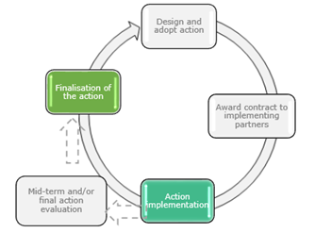

The purpose of reporting is to present the monitoring data for progress review and for accountability.
At Action level, the reporting responsibility lies with the Implementing Partners. The PI project managers lead the quality review with support of the PI User.

The new online platform, OPSYS, will be the support for any reporting. Implementing Partners will enter the monitoring data on OPSYS and PI managers will receive and review the reporting via OPSYS. The interface allows to collect information on:
  - Key features of the Action
  - Core indicators and/or customised indicators
  - Quantitative and qualitative data (the numerical value of any indicator is accompanied by a textbox to collect a qualitative narrative on the indicator considered) and the disaggregation required by the FPI
The FPI asks implementing partners to do cumulative reporting. It means that implementing partners will report the updated total value of indicators at each reporting deadline (they should not report only on the difference between reporting period t and reporting period t+1).
The implementing partners are required to report on indicators contained in their logframes. That will complement the progress reports submitted on a regular basis as required by the specific contract / TOR.
For those transitioning to OPSYS:
  - If you are implementing a PI-funded action and you are expected to report in 2020, you will be reporting using the PIMS indicator reporting template (see picture below) and in OPSYS. After 2020, reporting will only be done through OPSYS. For more information on how OPSYS works, please refer to the OPSYS guidelines.
  - Please note that the core activity indicators A1 and A3 have been reclassified in OPSYS. You can find them as output indicators, respectively as PI O.01 and PI O.11. You should enter the data under the corresponding indicators.
  - If you were required to report on the indicator A2, please report the data in the narrative report you are preparing for the PI manager.

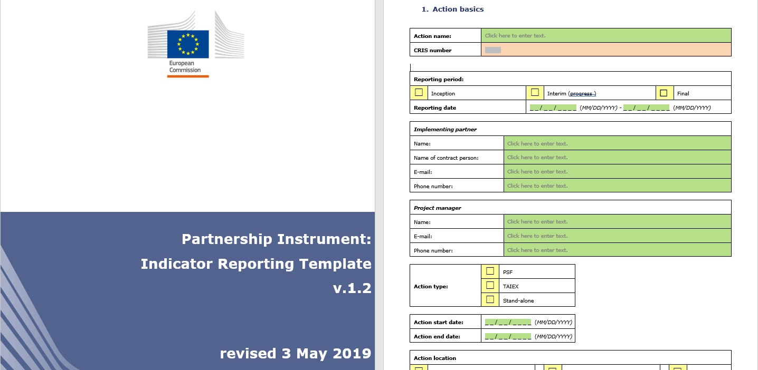

To summarise:
The following diagram details the responsibility and timings of reporting for Actions:

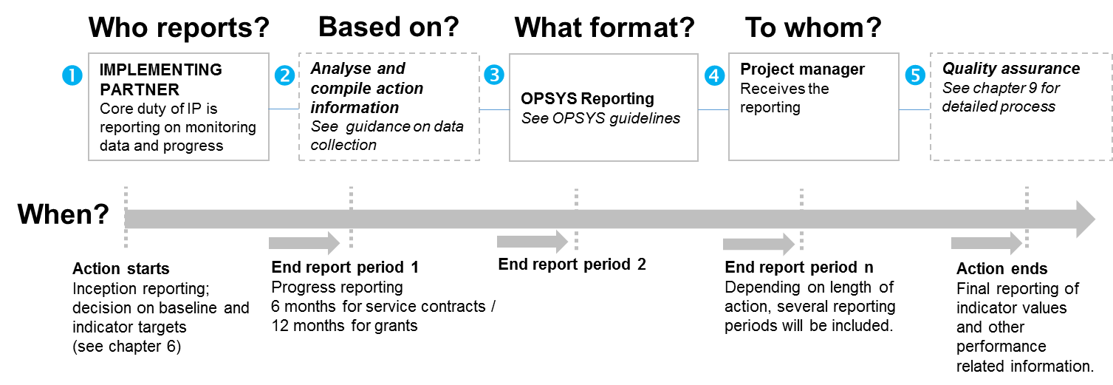

It is important to note the following things around reporting:
IPs have the main responsibility for the collection and reporting of Action level data, meeting reporting deadlines and providing accurate and reliable data.
Collection and analysis of the necessary data for reporting on progress is a recurring task under implementation. This is often done continuously during the project.
IPs upload the monitoring data and report in OPSYS. Reporting requirements and deadlines are set in the Terms of Reference / Agreements.
Implementing partners submit their reports to the project manager.
See chapter 9, for detailed explanation of the quality review process.
Tips: Use plain English. Ensure that the language is clear, unambiguous, without unexplained terminology or abbreviations, and avoid spelling mistakes.
Don’t miss a reporting deadline.

Quality review of reporting
The compliance, accuracy and completeness of the data reported is the main goal of the quality review. The data should be fit for its intended use in decision-making, evaluation of Actions and planning of the PI.
As long as the reporting is done using the PIMS indicator reporting templates, the tasks for all stakeholders (PI managers and implementing partners) remain as described in the following diagram: the only difference is that you will report the monitoring data in the indicator reporting template instead of uploading the data onto OPSYS.
Once the transition to OPSYS is completed, the data will be managed centrally via the IT system called OPSYS.
It is the role of the project manager to carry out quality review.

The diagrams below detail the process of quality review of reporting:

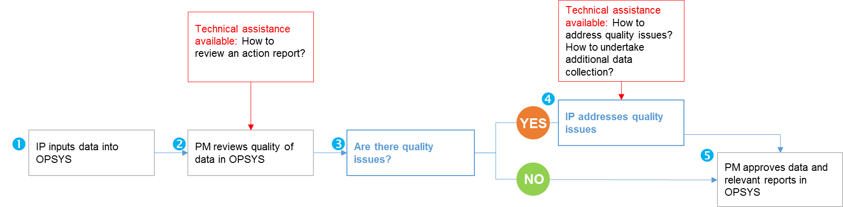
These are the following steps required in quality review of reporting:
IPs input data into OPSYS.
PMs review the data to ensure consistency, good quality and usefulness of the information available on actions. There is a PI-specific helpdesk that provides technical assistance on quality review.
If applicable, quality issues, “problems”, inconsistencies are identified and clearly communicated to IPs.
IPs are responsible for addressing the quality issues identified, revise and resubmit data.
PM approves data in OPSYS.
Tip: Quality review is essential. Ask the following questions:
Have you collected all the information you were supposed to?
Have you explained why some information was only partial? Have you taken the data collection limitations into consideration when drawing conclusions on the Action performance?
Are all sections of the reporting requirements and monitoring questions addressed?

For additional information
This guide should provide an overview of the PIMS process and how to carry out monitoring for Actions. However, if you still have a question, here is a list of additional documents that might be helpful:

- Better Regulation Guidelines, European Commission at http://ec.europa.eu/smart-regulation/guidelines/toc_tool_en.htm
- DAC’s glossary of key terms in evaluation and results-based management, OECD at https://www.oecd.org/dac/evaluation/2754804.pdf
- Full list of PI core indicators with definitions, examples for use, unit of measurement and disaggregation in Annex 1: PI core indicators
- Intervention logic template in Annex 2: Intervention Logic Template
- Logframe Matrix template in Annex 3: Logframe Matrix

As the different functionalities of OPSYS are rolled out progressively, you will find more information on the FPI website, on OPSYS itself, and on the intranet (for PI managers), as well as on https://europa.eu/capacity4dev/
Still have questions? As of November 2020, a new PIMS helpdesk will be available. You will receive an update with the contact details.

Annex 1: PI Core Indicators

List of indicators, unit of measurement and disaggregation

Output
Title |  | Unit of measurement | Disaggregation
Number of events organised or supported |  | Number  Narrative description of the topics | By type of event:  - Visits, exchanges, study tours  - Business missions  - Technical meetings (to discuss a specific technical subject)  - Group events (conferences, debates, workshops, seminars)  - Training  - Outreach and advocacy (including networking events, cultural collaboration activities)
Number of participants in the events organised/supported |  | Number | By gender  By sector of participants  - Academia and students  - Government  - Business/private sector  - Media  - Civil society  - Other  By type of event  - Visits, exchanges, study tours  - Business missions  - Technical meetings  - Group events  - Training  - Outreach and advocacy
Percentage of participants in the events who report having benefited from the events organised/supported |  | Percentage | By gender
Number of EU companies that participated in the events organised/supported |  | Number  Narrative description of business focus of the participating companies | By type of event  - Business missions  - Group events  - Trainings
Percentage of EU companies which report having benefited from the events organised/supported |  | Percentage | By type of event  - Business missions  - Group events  - Trainings
Number of non-EU companies that participated in the events organised/supported |  | Number  Narrative description of business focus of the participating companies | By type of event  - Business missions  - Group events  - Trainings
Percentage of non-EU companies which report having benefited from the events organised/supported |  | Percentage | By type of event  - Business missions  - Group events  - Trainings
Number of outcome statements emanating from the events |  | Number  Narrative description of the subject(s) covered by the official statement(s) | n/a
Number of knowledge-based products developed |  | Number  Narrative description of product type (e.g. study, report, publication, assessment, database, roadmap, guidelines, etc.)  Narrative description of the subject covered (e.g. climate change, trade barriers, migration, etc.) | n/a
Number of communication products developed |  | Number  Narrative description of communication product (e.g. article, opinion piece, press release, video interview, leaflet, etc.)  Narrative description of the subject covered (e.g. climate change, trade barriers, migration, etc.) | n/a
Number of public/media/communication campaigns designed and implemented |  | Number  Narrative description of the topic | n/a

Outcome
Title |  | Unit of measurement | Disaggregation
General
Number of processes related to state-level and sub-state level (bilateral, regional, multi-lateral) partnership strategies and policy dialogues which have been influenced |  | Number and narrative.  The narrative specifies the type of process being influenced and the subject of the process (for example “developing a strategic partnership on urbanisation”). It provides a narrative explanation of how the processes have been influenced in line with the objectives of the Action to justify the quantitative value reported. | n/a
Number of processes related to non-state level partnerships / agreements which have been influenced. |  | Number and narrative.  The narrative specifies the type of process being influenced and the subject of the process (for example “developing the Covenant of Mayors”). It provides a narrative explanation of how the processes have been influenced in line with the objectives of the Action to justify the quantitative value reported. | n/a
Number of processes related to partner country approaches to challenges of global concern which have been influenced. |  | Number and narrative.  The narrative specifies the type of process being influenced and the subject of the process (for example “processes related to emission standards”). It provides a narrative explanation of how the processes have been influenced in line with the objectives of the Action to justify the quantitative value reported. | n/a
Number of processes related to partner country practices on challenges of global concern which have been influenced |  | Number and narrative.  The narrative specifies the type of process being influenced and the subject of the process (for example “assisting with the drafting of low carbon legislation” or “bringing emissions standards in line with EU interests”). It provides a narrative explanation of how the processes have been influenced in line with the objectives of the Action to justify the quantitative value reported. | n/a
Number of processes related to the positions partner countries take in the run-up , or during, regional/ international fora which have been influenced |  | Number and narrative.  The narrative specifies the type of process being influenced and the subject of the process (for example “influencing the position to be taken at the UN Conference on Climate Change”). It provides a narrative explanation of how the processes have been influenced in line with the objectives of the Action to justify the quantitative value reported. | n/a
Number of processes related to partner country approaches beneficial to the achievement of the Europe 2020 strategy which have been influenced. |  | Number and narrative.  The narrative specifies the type of process being influenced and the subject of the process (for example “enhancing the processes related to dialogue on human rights”). It provides a narrative explanation of how the processes have been influenced in line with the objectives of the Action to justify the quantitative value reported. | n/a
Number of processes related to partner country practices beneficial to the achievement of Europe 2020 strategy which have been influenced. |  | Number and narrative.  The narrative specifies the type of process being influenced and the subject of the process (for example “influencing a stronger application of child labour laws” or “amending legislation regarding the treatment of illegal migrants). It provides a narrative explanation of how the processes have been influenced in line with the objectives of the Action to justify the quantitative value reported. | n/a
Trade-specific
Number of processes related to partner country practices on trade, investment and business which have been influenced. |  | Number and narrative.  The narrative specifies the type of process being influenced and the subject of the process (for example “developing legislation on trade in green goods”). It provides a narrative explanation of how the processes have been influenced in line with the objectives of the Action to justify the quantitative value reported. | n/a
Number of processes related to the removal of barriers to market access, investment and business which have been influenced. |  | Number and narrative.  The narrative specifies the type of process being influenced and the subject of the process (for example “removal of barriers to trade in renewables”). It provides a narrative explanation of how the processes have been influenced in line with the objectives of the Action to justify the quantitative value reported. | n/a
Number of processes related to the negotiation, implementation or enforcement of EU trade and investment agreements with partner countries which have been influenced |  | Number and narrative.  The narrative specifies the type of process being influenced and the subject of the process (for example “removal of restrictions on foreign direct investment”). It provides a narrative explanation of how the processes have been influenced in line with the objectives of the Action to justify the quantitative value reported. | n/a
Percentage of EU companies’ which acknowledge a positive change in their perceptions of the business, trade and investment climate in partner countries |  | Percentage | n/a
Advocacy
Percentage of participants targeted by outreach and advocacy events who acknowledge a positive change in their perception of the EU and/or international policies and standards |  | Percentage | By gender
Percentage of participants targeted by outreach and advocacy events who acknowledge having engaged further on the topic on their own initiative as a result of their exposure to an event |  | Percentage | By gender
Number of articles published in print and/or digital media about an event |  | Number  Narrative description of the tone (positive, neutral - factual, negative) of the article(s)  Narrative description of the subject(s) covered by the article(s)  Name of the print and/or digital media | n/a

Impact
Title | Unit of measurement | Disaggregation
Number of EU bilateral, regional, inter-regional and multi-lateral cooperation partnership strategies which have been enhanced | Number and narrative.  The narrative specifies the partnership strategy being enhanced (such as EU-[country] framework agreement or EU-[country] strategic partnership) and provides a narrative explanation of how the strategy has been enhanced in line with the objectives of the Action to justify the quantitative value reported. | n/a
Number of collective approaches and/or practices to challenges of global and/or mutual concern which have been developed/adopted/implemented | Number and narrative.  The narrative specifies the challenges being addressed jointly by the EU and the partner country in global and/or their mutual interest (e.g. adoption of binding methane emissions reduction targets) and provides a narrative explanation of how the approaches and/or practices have been developed/adopted/implemented in line with the objectives of the Action to justify the quantitative value reported. | n/a
Number of approaches and/or practices beneficial to the achievement of the EU2020 strategy which have been taken up in partner countries | Number and narrative.  The narrative specifies the strategy being influenced in the partner country and beneficial to the EU (such as the development by a partner country of an approach towards illegal migration) and provides a narrative explanation of how the strategy has been influenced in line with the objectives of the Action to justify the quantitative value reported. | n/a
Number of regulations and standards relating to trade, investment and business in partner countries which have been aligned to EU / international standards | Number and narrative.  The narrative specifies the regulations and standards which have been aligned to EU / international standards and provides a narrative explanation of how the alignment has been achieved in line with the objectives of the Action to justify the quantitative value reported. | n/a
Number of barriers to market access, investment and business development which have been removed | Number and narrative.  The narrative specifies which barriers have been removed and provides a narrative explanation of how it was made possible in line with the objectives of the Action to justify the quantitative value reported. | n/a

PI core indicators fiches

Annex 2: Intervention Logic Template
OUTPUTS
ACTIVITIES
SPECIFIC OBJECTIVES
OVERALL OBJECTIVES
INPUTS
NEEDS / PROBLEMS TO BE ADDRESSED
OPPORTUNITIES

You can open the editable template from the icon below:

Annex 3: Logframe Matrix

You will design the LFM on OPSYS, and you will be able to print out the LFM from the platform. If this is helpful, you might use the template here to draft the logframe, before entering it on OPSYS.
Results Chain |  | Indicators | Baselines (including reference year) | Targets (including reference year) | Source of verification | Assumptions
Overall Objective - Impact |  |  |  |  |  | Not to be filled in
Specific Objective(s) - Outcomes
Outputs
Activities

You can open the editable template from the icon below:

When programming an intervention, we speak in terms of goals and use the following terminology: specific objectives, overall objectives. When implementing an intervention, we monitor what results we are achieving/contributing to and we talk about outcomes and impacts.
The presentation of PI IL has been adjusted to be useful for Action level. It therefore differs from the general approach presented in the FPI Manual.
As of September 2019, but the list might be revised based on the evolution of actions over time.
It is important to keep in mind the disaggregated information needed when doing the data collection. Implementing partners will select the most suitable category under which they will report: e.g. is the event organised a business mission or a technical meeting? Even when an event has multiple purposes (e.g. if it combines a technical meeting and a training on ICT standards), only one category can be selected to avoid double counting. The most suitable type is to be chosen, but there is no golden rule for this.
Guidelines will be made available on OPSYS before the launch of the first reporting exercise through OPSYS.
In 2019 and for the last time, reports will be submitted via email using the PIMS indicator reporting template and via OPSYS.
It is important to keep in mind the disaggregated information needed when doing the data collection. Implementing partners will select the most suitable category under which they will report: e.g. is the event organised a business mission or a technical meeting? Even when an event has multiple purposes (e.g. if it combines a technical meeting and a training on ICT standards), only one category can be selected to avoid double counting. The most suitable type is to be chosen, but there is no golden rule for this.

